ML | Linear Regression
Linear Regression is a machine learning algorithm based on supervised learning. It performs a regression task. Regression models a target prediction value based on independent variables. It is mostly used for finding out the relationship between variables and forecasting. Different regression models differ based on – the kind of relationship between dependent and independent variables they are considering, and the number of independent variables getting used.
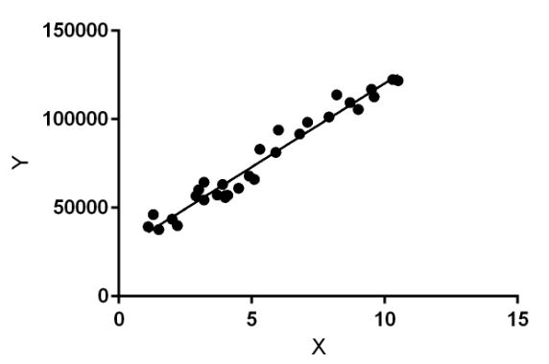


Linear regression performs the task to predict a dependent variable value (y) based on a given independent variable (x). So, this regression technique finds out a linear relationship between x (input) and y(output). Hence, the name is Linear Regression.
In the figure above, X (input) is the work experience and Y (output) is the salary of a person. The regression line is the best fit line for our model.
Hypothesis function for Linear Regression :
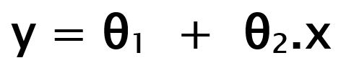
While training the model we are given :
x: input training data (univariate – one input variable(parameter))
y: labels to data (supervised learning)
When training the model – it fits the best line to predict the value of y for a given value of x. The model gets the best regression fit line by finding the best θ1 and θ2 values.
θ1: intercept
θ2: coefficient of x
Once we find the best θ1 and θ2 values, we get the best fit line. So when we are finally using our model for prediction, it will predict the value of y for the input value of x.
How to update θ1 and θ2 values to get the best fit line ?
Cost Function (J):
By achieving the best-fit regression line, the model aims to predict y value such that the error difference between predicted value and true value is minimum. So, it is very important to update the θ1 and θ2 values, to reach the best value that minimize the error between predicted y value (pred) and true y value (y).
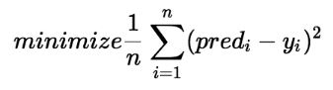
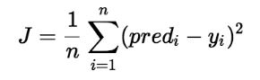
Cost function(J) of Linear Regression is the Root Mean Squared Error (RMSE) between predicted y value (pred) and true y value (y).
Gradient Descent:
To update θ1 and θ2 values in order to reduce Cost function (minimizing RMSE value) and achieving the best fit line the model uses Gradient Descent. The idea is to start with random θ1 and θ2 values and then iteratively updating the values, reaching minimum cost.

Gradient Descent in Linear Regression
In linear regression, the model targets to get the best-fit regression line to predict the value of y based on the given input value (x). While training the model, the model calculates the cost function which measures the Root Mean Squared error between the predicted value (pred) and true value (y). The model targets to minimize the cost function.
To minimize the cost function, the model needs to have the best value of θ1 and θ2. Initially model selects θ1 and θ2 values randomly and then iteratively update these value in order to minimize the cost function until it reaches the minimum. By the time model achieves the minimum cost function, it will have the best θ1 and θ2 values. Using these finally updated values of θ1 and θ2 in the hypothesis equation of linear equation, the model predicts the value of x in the best manner it can.
Therefore, the question arises – How do θ1 and θ2 values get updated?
Linear Regression Cost Function:

Gradient Descent Algorithm For Linear Regression
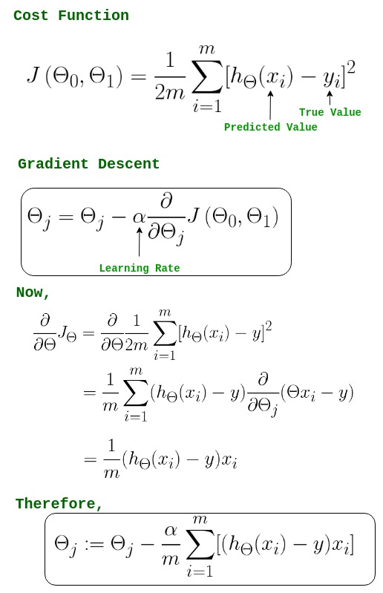

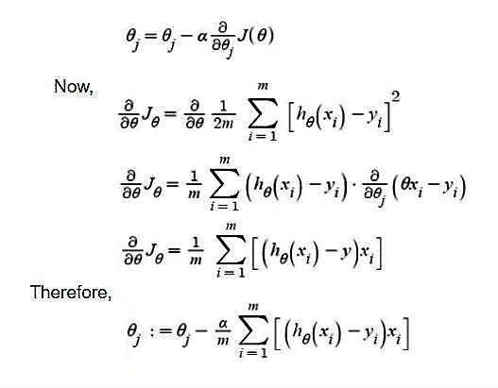

-> θj : Weights of the hypothesis.
-> hθ(xi) : predicted y value for ith input.
-> j : Feature index number (can be 0, 1, 2, ......, n).
-> α : Learning Rate of Gradient Descent.
We graph cost function as a function of parameter estimates i.e. parameter range of our hypothesis function and the cost resulting from selecting a particular set of parameters. We move downward towards pits in the graph, to find the minimum value. The way to do this is taking derivative of cost function as explained in the above figure. Gradient Descent step-downs the cost function in the direction of the steepest descent. The size of each step is determined by parameter α known as Learning Rate.
In the Gradient Descent algorithm, one can infer two points :
- If slope is +ve : θj = θj – (+ve value). Hence value of θj decreases.
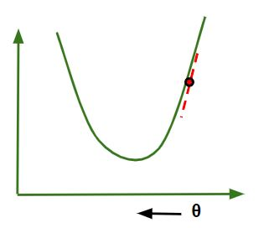
- If slope is -ve : θj = θj – (-ve value). Hence value of θj increases.
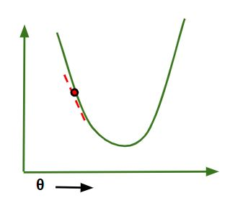
The choice of correct learning rate is very important as it ensures that Gradient Descent converges in a reasonable time. :
- If we choose α to be very large, Gradient Descent can overshoot the minimum. It may fail to converge or even diverge.
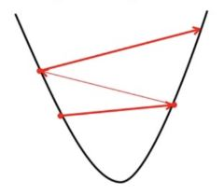
- If we choose α to be very small, Gradient Descent will take small steps to reach local minima and will take a longer time to reach minima.
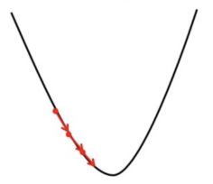
For linear regression Cost, the Function graph is always convex shaped.

# Implementation of gradient descent in linear regression
import numpy as np
import matplotlib.pyplot as plt

class Linear_Regression:
def __init__(self, X, Y):
self.X = X
self.Y = Y
self.b = [0, 0]

def update_coeffs(self, learning_rate):
Y_pred = self.predict()
Y = self.Y
m = len(Y)
self.b[0] = self.b[0] - (learning_rate * ((1/m) *
np.sum(Y_pred - Y)))

self.b[1] = self.b[1] - (learning_rate * ((1/m) *
np.sum((Y_pred - Y) * self.X)))

def predict(self, X=[]):
Y_pred = np.array([])
if not X: X = self.X
b = self.b
for x in X:
Y_pred = np.append(Y_pred, b[0] + (b[1] * x))

return Y_pred

def get_current_accuracy(self, Y_pred):
p, e = Y_pred, self.Y
n = len(Y_pred)
return 1-sum(
[
abs(p[i]-e[i])/e[i]
for i in range(n)
if e[i] != 0]
)/n
#def predict(self, b, yi):

def compute_cost(self, Y_pred):
m = len(self.Y)
J = (1 / 2*m) * (np.sum(Y_pred - self.Y)**2)
return J

def plot_best_fit(self, Y_pred, fig):
f = plt.figure(fig)
plt.scatter(self.X, self.Y, color='b')
plt.plot(self.X, Y_pred, color='g')
f.show()

def main():
X = np.array([i for i in range(11)])
Y = np.array([2*i for i in range(11)])

regressor = Linear_Regression(X, Y)

iterations = 0
steps = 100
learning_rate = 0.01
costs = []

#original best-fit line
Y_pred = regressor.predict()
regressor.plot_best_fit(Y_pred, 'Initial Best Fit Line')

while 1:
Y_pred = regressor.predict()
cost = regressor.compute_cost(Y_pred)
costs.append(cost)
regressor.update_coeffs(learning_rate)

iterations += 1
if iterations % steps == 0:
print(iterations, "epochs elapsed")
print("Current accuracy is :",
regressor.get_current_accuracy(Y_pred))

stop = input("Do you want to stop (y/*)??")
if stop == "y":
break

#final best-fit line
regressor.plot_best_fit(Y_pred, 'Final Best Fit Line')

#plot to verify cost function decreases
h = plt.figure('Verification')
plt.plot(range(iterations), costs, color='b')
h.show()

# if user wants to predict using the regressor:
regressor.predict([i for i in range(10)])

if __name__ == '__main__':
main()

Output:
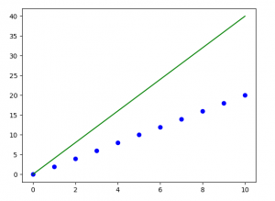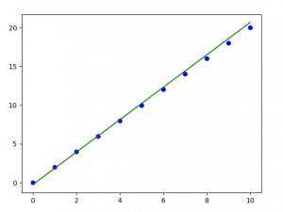
Note: Gradient descent sometimes is also implemented using Regularization.

Mathematical explanation for Linear Regression working
Suppose we are given a dataset

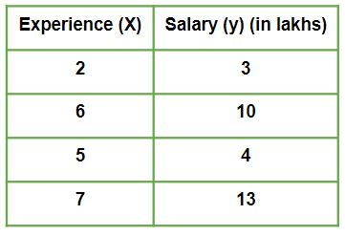
Given is a Work vs Experience dataset of a company and the task is to predict the salary of a employee based on his / her work experience.
This article aims to explain how in reality Linear regression mathematically works when we use a pre-defined function to perform prediction task.
Let us explore how the stuff works when Linear Regression algorithm gets trained.
Iteration 1 – In the start, θ0 and θ1 values are randomly chosen. Let us suppose, θ0 = 0 and θ1 = 0.
- Predicted values after iteration 1 with Linear regression hypothesis.
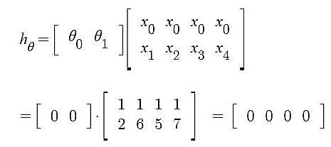
- Cost Function – Error
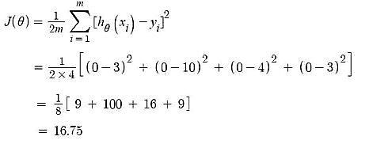
- Gradient Descent – Updating θ0 value
Here, j = 0
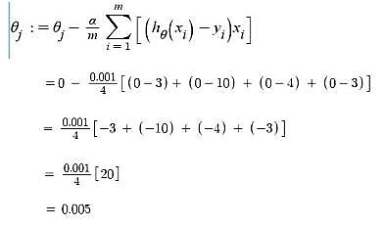
- Gradient Descent – Updating θ1 value
Here, j = 1
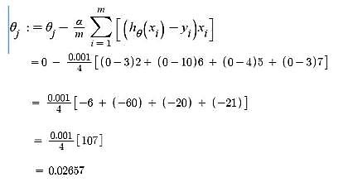
Iteration 2 – θ0 = 0.005 and θ1 = 0.02657
- Predicted values after iteration 1 with Linear regression hypothesis.
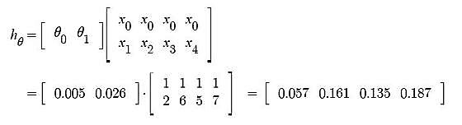
Now, similar to iteration no. 1 performed above we will again calculate Cost function and update θj values using Gradient Descent.
We will keep on iterating until Cost function doesn’t reduce further. At that point, model achieves best θ values. Using these θ values in the model hypothesis will give the best prediction results.

ML | Normal Equation in Linear Regression
Normal Equation is an analytical approach to Linear Regression with a Least Square Cost Function. We can directly find out the value of θ without using Gradient Descent. Following this approach is an effective and time-saving option when working with a dataset with small features. Normal Equation method is based on the mathematical concept of Maxima & Minima in which the derivative and partial derivative of any function would be zero at the minima and maxima point. So, in Normal Equation method, we get the minimum value of the Cost function by finding its partial derivative w.r.t to each weight and equating it to zero.

The normal Equation is as follows:
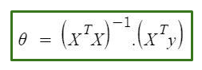
In the above equation,
θ: hypothesis parameters that define it the best.
X: Input feature value of each instance.
Y: Output value of each instance.

Maths Behind the equation:
Given the hypothesis function
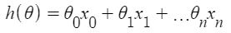
where,
n: the no. of features in the data set.
x0: 1 (for vector multiplication)
Notice that this is a dot product between θ and x values. So for the convenience to solve we can write it as:
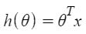
The motive in Linear Regression is to minimize the cost function:
J(\Theta) = \frac{1}{2m} \sum_{i = 1}^{m} \frac{1}{2} [h_{\Theta}(x^{(i)}) – y^{(i)}]^{2}
where,
xi: the input value of iih training example.
m: no. of training instances
n: no. of data-set features
yi: the expected result of ith instance
Let us represent the cost function in a vector form.
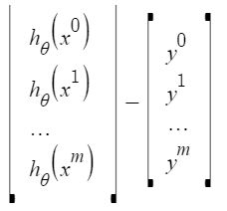
We have ignored 1/2m here as it will not make any difference in the working. It was used for mathematical convenience while calculating gradient descent. But it is no more needed here.
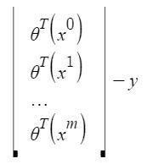
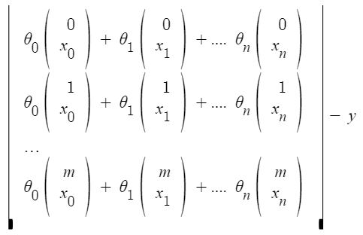
xij: value of jih feature in iih training example.
This can further be reduced to
But each residual value is squared. We cannot simply square the above expression. As the square of a vector/matrix is not equal to the square of each of its values. So to get the squared value, multiply the vector/matrix with its transpose. So, the final equation derived is
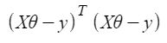
Therefore, the cost function is
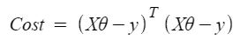
So, now getting the value of θ using the partial derivative
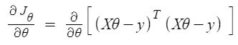
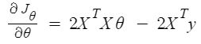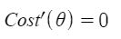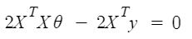
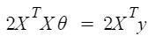
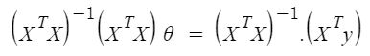
So, this is the finally derived Normal Equation with θ giving the minimum cost value.
Example:

# This code may not run on GFG IDE
# as required modules not found.

# import required modules
import numpy as np
import matplotlib.pyplot as plt
from sklearn.datasets import make_regression

# Create data set.
x, y = make_regression(n_samples=100, n_features=1,
n_informative=1, noise=10, random_state=10)

# Plot the generated data set.
plt.scatter(x, y, s=30, marker='o')
plt.xlabel("Feature_1 --->")
plt.ylabel("Target_Variable --->")
plt.title('Simple Linear Regression')
plt.show()

# Convert target variable array from 1d to 2d.
y = y.reshape(100, 1)

Output:
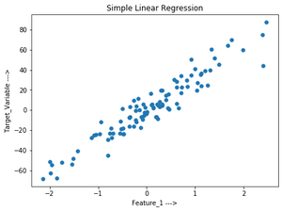
Let’s implement the Normal Equation:

# code

# Adding x0=1 to each instance
x_new = np.array([np.ones(len(x)), x.flatten()]).T

# Using Normal Equation.
theta_best_values = np.linalg.inv(x_new.T.dot(x_new)).dot(x_new.T).dot(y)

# Display best values obtained.
print(theta_best_values)

[[ 0.52804151]
[30.65896337]]
Try to predict for new data instance:

# sample data instance.
x_sample = np.array([[-2], [4]])

# Adding x0=1 to each instance.
x_sample_new = np.array([np.ones(len(x_sample)), x_sample.flatten()]).T

# Display the sample.
print("Before adding x0:\n", x_sample)
print("After adding x0:\n", x_sample_new)

Before adding x0:
[[-2]
[ 4]]
After adding x0:
[[ 1. -2.]
[ 1. 4.]]

# code
# predict the values for given data instance.
predict_value=x_sample_new.dot(theta_best_values)
print(predict_value)

[[-60.78988524]
[123.16389501]]

Plot the output:

# code

# Plot the output.
plt.scatter(x,y,s=30,marker='o')
plt.plot(x_sample,predict_value,c='red')
plt.plot()
plt.xlabel("Feature_1 --->")
plt.ylabel("Target_Variable --->")
plt.title('Simple Linear Regression')
plt.show()

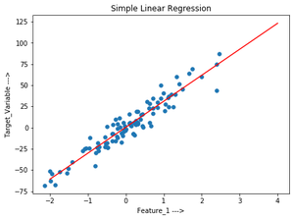
Verify the above using sklearn LinearRegression class:

# code

# Verification.
from sklearn.linear_model import LinearRegression
lr=LinearRegression() # Object.
lr.fit(x,y) # fit method.

# Print obtained theta values.
print("Best value of theta:",lr.intercept_,lr.coef_,sep='\n')

#predict.
print("predicted value:",lr.predict(x_sample),sep='\n')

Best value of theta:
[0.52804151]
[[30.65896337]]

predicted value:
[[-60.78988524]
[123.16389501]]

Linear Regression (Python Implementation)
This article discusses the basics of linear regression and its implementation in the Python programming language.
Linear regression is a statistical method for modeling relationships between a dependent variable with a given set of independent variables.

Note: In this article, we refer to dependent variables as responses and independent variables as features for simplicity.
In order to provide a basic understanding of linear regression, we start with the most basic version of linear regression, i.e. Simple linear regression.

Simple Linear Regression
Simple linear regression is an approach for predicting a response using a single feature.
It is assumed that the two variables are linearly related. Hence, we try to find a linear function that predicts the response value(y) as accurately as possible as a function of the feature or independent variable(x).
Let us consider a dataset where we have a value of response y for every feature x:
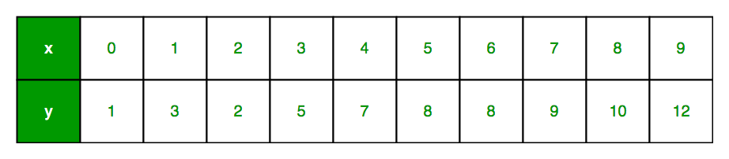
For generality, we define:
x as feature vector, i.e x = [x_1, x_2, …., x_n],
y as response vector, i.e y = [y_1, y_2, …., y_n]
for n observations (in above example, n=10).
A scatter plot of the above dataset looks like:-
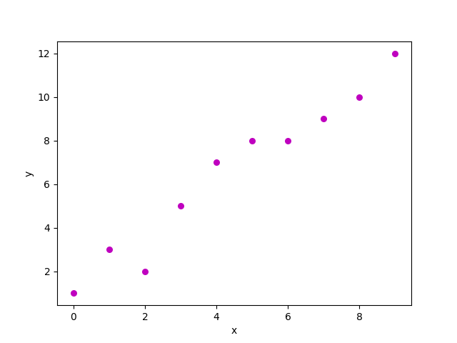
Now, the task is to find a line that fits best in the above scatter plot so that we can predict the response for any new feature values. (i.e a value of x not present in a dataset)
This line is called a regression line.
The equation of regression line is represented as:
Here,
- h(x_i) represents the predicted response value for ith observation.
- b_0 and b_1 are regression coefficients and represent y-intercept and slope of regression line respectively.
To create our model, we must “learn” or estimate the values of regression coefficients b_0 and b_1. And once we’ve estimated these coefficients, we can use the model to predict responses!
In this article, we are going to use the principle of Least Squares.
Now consider:
Here, e_i is a residual error in ith observation.
So, our aim is to minimize the total residual error.
We define the squared error or cost function, J as:
and our task is to find the value of b_0 and b_1 for which J(b_0,b_1) is minimum!
Without going into the mathematical details, we present the result here:
where SS_xy is the sum of cross-deviations of y and x:
and SS_xx is the sum of squared deviations of x:
Note: The complete derivation for finding least squares estimates in simple linear regression can be found here.
Code: Python implementation of above technique on our small dataset

import numpy as np
import matplotlib.pyplot as plt

def estimate_coef(x, y):
# number of observations/points
n = np.size(x)

# mean of x and y vector
m_x = np.mean(x)
m_y = np.mean(y)

# calculating cross-deviation and deviation about x
SS_xy = np.sum(y*x) - n*m_y*m_x
SS_xx = np.sum(x*x) - n*m_x*m_x

# calculating regression coefficients
b_1 = SS_xy / SS_xx
b_0 = m_y - b_1*m_x

return (b_0, b_1)

def plot_regression_line(x, y, b):
# plotting the actual points as scatter plot
plt.scatter(x, y, color = "m",
marker = "o", s = 30)

# predicted response vector
y_pred = b[0] + b[1]*x

# plotting the regression line
plt.plot(x, y_pred, color = "g")

# putting labels
plt.xlabel('x')
plt.ylabel('y')

# function to show plot
plt.show()

def main():
# observations / data
x = np.array([0, 1, 2, 3, 4, 5, 6, 7, 8, 9])
y = np.array([1, 3, 2, 5, 7, 8, 8, 9, 10, 12])

# estimating coefficients
b = estimate_coef(x, y)
print("Estimated coefficients:\nb_0 = {} \
\nb_1 = {}".format(b[0], b[1]))

# plotting regression line
plot_regression_line(x, y, b)

if __name__ == "__main__":
main()

Output:
Estimated coefficients:
b_0 = -0.0586206896552
b_1 = 1.45747126437
And graph obtained looks like this:
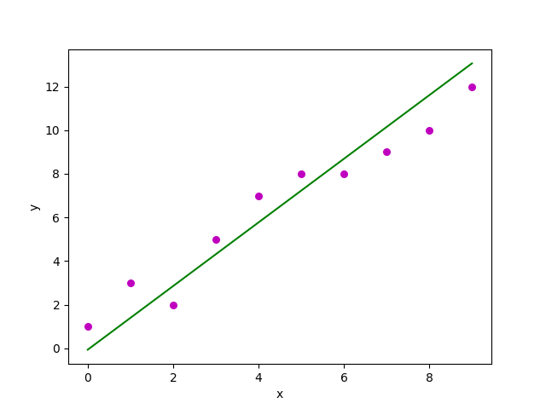

Multiple linear regression
Multiple linear regression attempts to model the relationship between two or more features and a response by fitting a linear equation to the observed data.
Clearly, it is nothing but an extension of simple linear regression.
Consider a dataset with p features(or independent variables) and one response(or dependent variable).
Also, the dataset contains n rows/observations.
We define:
X (feature matrix) = a matrix of size n X p where x_{ij} denotes the values of jth feature for ith observation.
So,
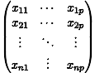
and
y (response vector) = a vector of size n where y_{i} denotes the value of response for ith observation.
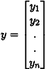
The regression line for p features is represented as:
where h(x_i) is predicted response value for ith observation and b_0, b_1, …, b_p are the regression coefficients.
Also, we can write:
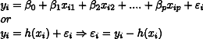
where e_i represents residual error in ith observation.
We can generalize our linear model a little bit more by representing feature matrix X as:
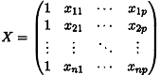
So now, the linear model can be expressed in terms of matrices as:
where,
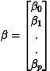
and
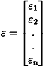
Now, we determine an estimate of b, i.e. b’ using the Least Squares method.
As already explained, the Least Squares method tends to determine b’ for which total residual error is minimized.
We present the result directly here:
where ‘ represents the transpose of the matrix while -1 represents the matrix inverse.
Knowing the least square estimates, b’, the multiple linear regression model can now be estimated as:
where y’ is the estimated response vector.
Note: The complete derivation for obtaining least square estimates in multiple linear regression can be found here.
Code: Python implementation of multiple linear regression techniques on the Boston house pricing dataset using Scikit-learn.

import matplotlib.pyplot as plt
import numpy as np
from sklearn import datasets, linear_model, metrics

# load the boston dataset
boston = datasets.load_boston(return_X_y=False)

# defining feature matrix(X) and response vector(y)
X = boston.data
y = boston.target

# splitting X and y into training and testing sets
from sklearn.model_selection import train_test_split
X_train, X_test, y_train, y_test = train_test_split(X, y, test_size=0.4,
random_state=1)

# create linear regression object
reg = linear_model.LinearRegression()

# train the model using the training sets
reg.fit(X_train, y_train)

# regression coefficients
print('Coefficients: ', reg.coef_)

# variance score: 1 means perfect prediction
print('Variance score: {}'.format(reg.score(X_test, y_test)))

# plot for residual error

## setting plot style
plt.style.use('fivethirtyeight')

## plotting residual errors in training data
plt.scatter(reg.predict(X_train), reg.predict(X_train) - y_train,
color = "green", s = 10, label = 'Train data')

## plotting residual errors in test data
plt.scatter(reg.predict(X_test), reg.predict(X_test) - y_test,
color = "blue", s = 10, label = 'Test data')

## plotting line for zero residual error
plt.hlines(y = 0, xmin = 0, xmax = 50, linewidth = 2)

## plotting legend
plt.legend(loc = 'upper right')

## plot title
plt.title("Residual errors")

## method call for showing the plot
plt.show()

Output:
Coefficients:
[ -8.80740828e-02 6.72507352e-02 5.10280463e-02 2.18879172e+00
-1.72283734e+01 3.62985243e+00 2.13933641e-03 -1.36531300e+00
2.88788067e-01 -1.22618657e-02 -8.36014969e-01 9.53058061e-03
-5.05036163e-01]
Variance score: 0.720898784611
and Residual Error plot looks like this:
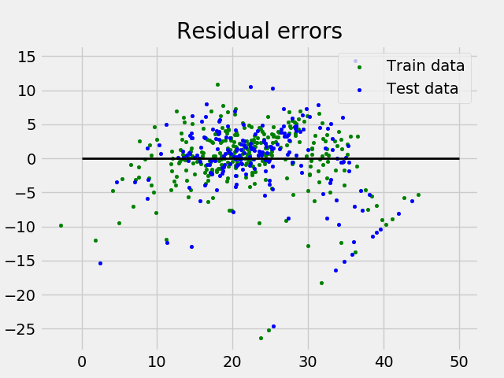
In the above example, we determine the accuracy score using Explained Variance Score.
We define:
explained_variance_score = 1 – Var{y – y’}/Var{y}
where y’ is the estimated target output, y the corresponding (correct) target output, and Var is Variance, the square of the standard deviation.
The best possible score is 1.0, lower values are worse.

Assumptions:
Given below are the basic assumptions that a linear regression model makes regarding a dataset on which it is applied:
- Linear relationship: Relationship between response and feature variables should be linear. The linearity assumption can be tested using scatter plots. As shown below, 1st figure represents linearly related variables whereas variables in the 2nd and 3rd figures are most likely non-linear. So, 1st figure will give better predictions using linear regression.
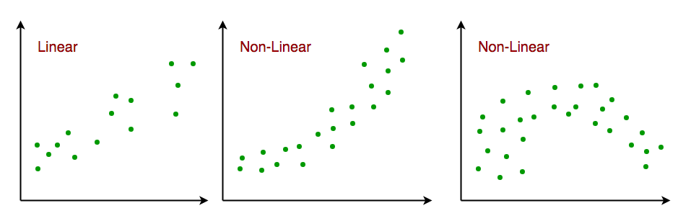
- Little or no multi-collinearity: It is assumed that there is little or no multicollinearity in the data. Multicollinearity occurs when the features (or independent variables) are not independent of each other.
- Little or no auto-correlation: Another assumption is that there is little or no autocorrelation in the data. Autocorrelation occurs when the residual errors are not independent of each other. You can refer here for more insight into this topic.
- Homoscedasticity: Homoscedasticity describes a situation in which the error term (that is, the “noise” or random disturbance in the relationship between the independent variables and the dependent variable) is the same across all values of the independent variables. As shown below, figure 1 has homoscedasticity while figure 2 has heteroscedasticity.
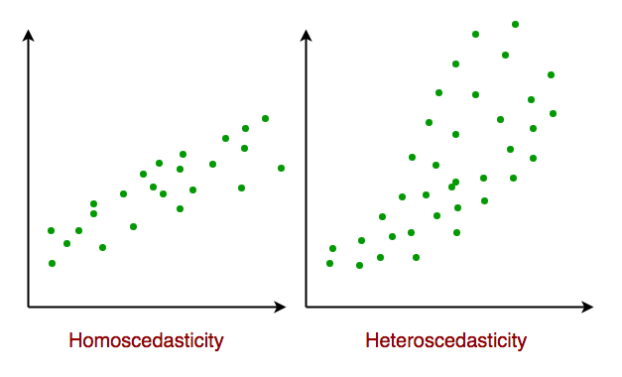
As we reach the end of this article, we discuss some applications of linear regression below.

Applications:
- Trend lines: A trend line represents the variation in quantitative data with the passage of time (like GDP, oil prices, etc.). These trends usually follow a linear relationship. Hence, linear regression can be applied to predict future values. However, this method suffers from a lack of scientific validity in cases where other potential changes can affect the data.
- Economics: Linear regression is the predominant empirical tool in economics. For example, it is used to predict consumer spending, fixed investment spending, inventory investment, purchases of a country’s exports, spending on imports, the demand to hold liquid assets, labor demand, and labor supply.
- Finance: The capital price asset model uses linear regression to analyze and quantify the systematic risks of an investment.
4. Biology: Linear regression is used to model causal relationships between parameters in biological systems.

References:
- https://en.wikipedia.org/wiki/Linear_regression
- https://en.wikipedia.org/wiki/Simple_linear_regression
- http://scikit-learn.org/stable/auto_examples/linear_model/plot_ols.html
- http://www.statisticssolutions.com/assumptions-of-linear-regression/

R | Simple Linear Regression
Linear Regression: It is a commonly used type of predictive analysis. It is a statistical approach for modeling the relationship between a dependent variable and a given set of independent variables.

There are two types of linear regression.
- Simple Linear Regression
- Multiple Linear Regression
Let’s discuss Simple Linear regression using R.

Simple Linear Regression:
It is a statistical method that allows us to summarize and study relationships between two continuous (quantitative) variables. One variable denoted x is regarded as an independent variable and the other one denoted y is regarded as a dependent variable. It is assumed that the two variables are linearly related. Hence, we try to find a linear function that predicts the response value(y) as accurately as possible as a function of the feature or independent variable(x).
For understanding the concept let’s consider a salary dataset where it is given the value of the dependent variable(salary) for every independent variable(years experienced).
Salary dataset:
Years experienced Salary

1.1 39343.00
1.3 46205.00
1.5 37731.00
2.0 43525.00
2.2 39891.00
2.9 56642.00
3.0 60150.00
3.2 54445.00
3.2 64445.00
3.7 57189.00
For general purpose, we define:
- x as a feature vector, i.e x = [x_1, x_2, …., x_n],
- y as a response vector, i.e y = [y_1, y_2, …., y_n]
- for n observations (in above example, n=10).

Scatter plot of given dataset:
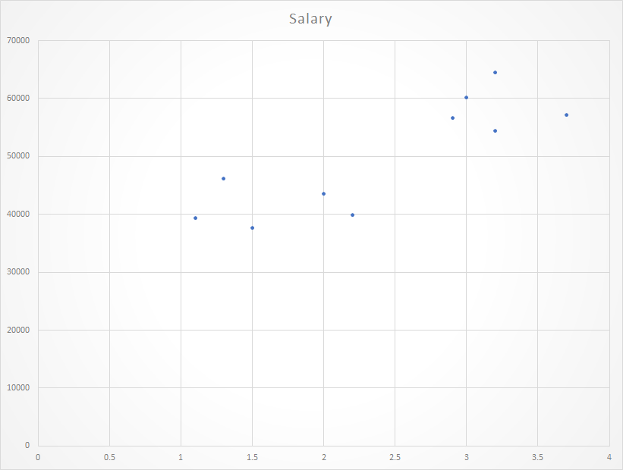
Now, we have to find a line that fits the above scatter plot through which we can predict any value of y or response for any value of x
The line which best fits is called the Regression line.
The equation of regression line is given by:
y = a + bx
Where y is the predicted response value, a is the y-intercept, x is the feature value and b is a slope.
To create the model, let’s evaluate the values of regression coefficient a and b. And as soon as the estimation of these coefficients is done, the response model can be predicted. Here we are going to use Least Square Technique.
The principle of least squares is one of the popular methods for finding a curve fitting a given data. Say (x1, y1), (x2, y2)….(xn, yn) be n observations from an experiment. We are interested in finding a curve
Closely fitting the given data of size ‘n’. Now at x=x1 while the observed value of y is y1 the expected value of y from curve (1) is f(x1). Then the residual can be defined by…
Similarly residual for x2, x3…xn are given by …
While evaluating the residual we will find that some residuals are positives and some are negatives. We are looking forward to finding the curve fitting the given data such that residual at any xi is minimum. Since some of the residuals are positive and others are negative and as we would like to give equal importance to all the residuals it is desirable to consider the sum of the squares of these residuals. Thus we consider:
and find the best representative curve.
Least Square Fit of a Straight Line
Suppose, given a dataset (x1, y1), (x2, y2), (x3, y3)…..(xn, yn) of n observation from an experiment. And we are interested in fitting a straight line.
to the given data.
Now consider:
Now consider the sum of the squares of ei
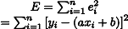
Note: E is a function of parameters a and b and we need to find a and b such that E is minimum and the necessary condition for E to be minimum is as follows:
This condition yields:
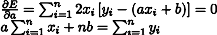
The above two equations are called normal equations which are solved to get the value of a and b.
The Expression for E can be rewritten as:
The basic syntax for a regression analysis in R is
lm(Y ~ model)
where Y is the object containing the dependent variable to be predicted and model is the formula for the chosen mathematical model.
The command lm( ) provides the model’s coefficients but no further statistical information.
Following R code is used to implement SIMPLE LINEAR REGRESSION:

# Simple Linear Regression
# Importing the dataset
dataset = read.csv('salary.csv')

# Splitting the dataset into the
# Training set and Test set
install.packages('caTools')
library(caTools)
split = sample.split(dataset$Salary, SplitRatio = 0.7)
trainingset = subset(dataset, split == TRUE)
testset = subset(dataset, split == FALSE)

# Fitting Simple Linear Regression to the Training set
lm.r= lm(formula = Salary ~ YearsExperience,
data = trainingset)
coef(lm.r)

# Predicting the Test set results
ypred = predict(lm.r, newdata = testset)

install.packages("ggplot2")
library(ggplot2)

# Visualising the Training set results
ggplot() + geom_point(aes(x = trainingset$YearsExperience,
y = trainingset$Salary), colour = 'red') +
geom_line(aes(x = trainingset$YearsExperience,
y = predict(lm.r, newdata = trainingset)), colour = 'blue') +

ggtitle('Salary vs Experience (Training set)') +
xlab('Years of experience') +
ylab('Salary')

# Visualising the Test set results
ggplot() +
geom_point(aes(x = testset$YearsExperience, y = testset$Salary),
colour = 'red') +
geom_line(aes(x = trainingset$YearsExperience,
y = predict(lm.r, newdata = trainingset)),
colour = 'blue') +
ggtitle('Salary vs Experience (Test set)') +
xlab('Years of experience') +
ylab('Salary')

Output of coef(lm.r):
Visualizing the Training set results:
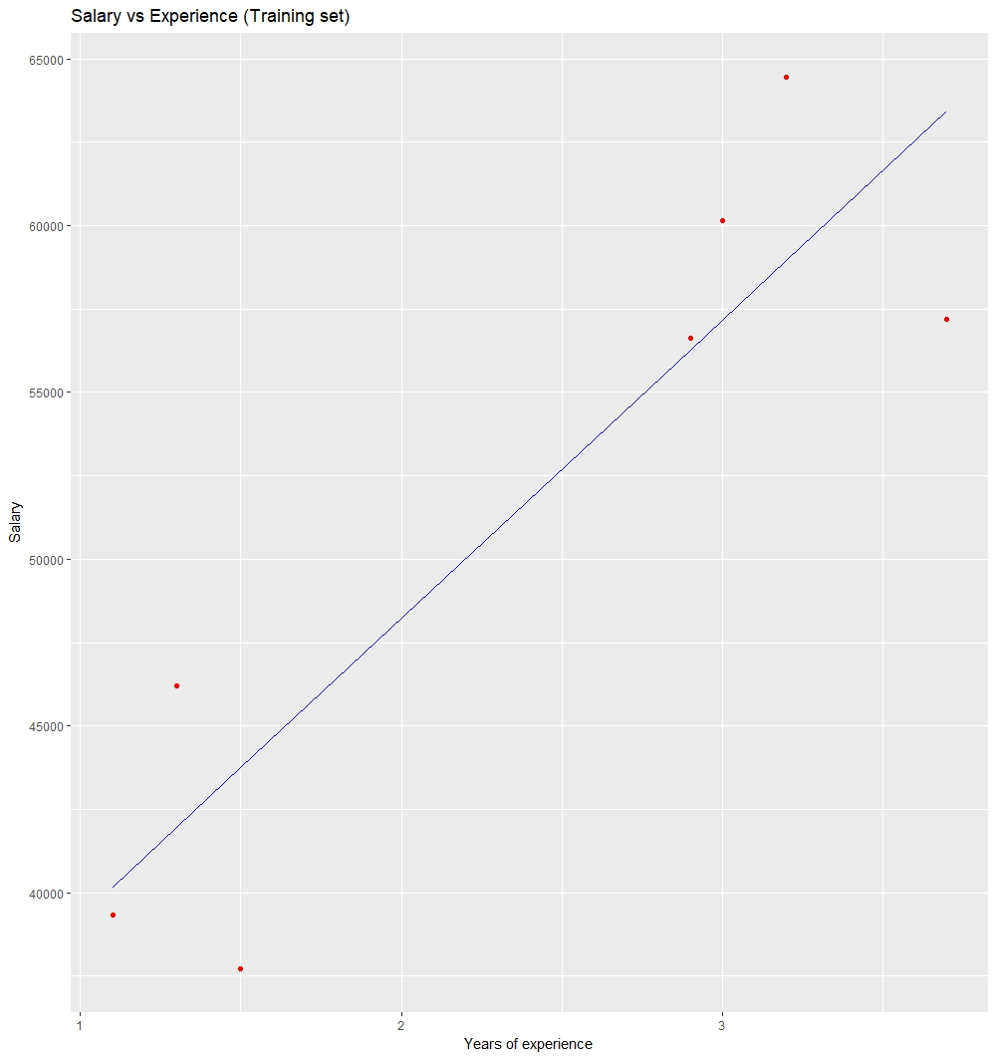
Visualizing the Testing set results:
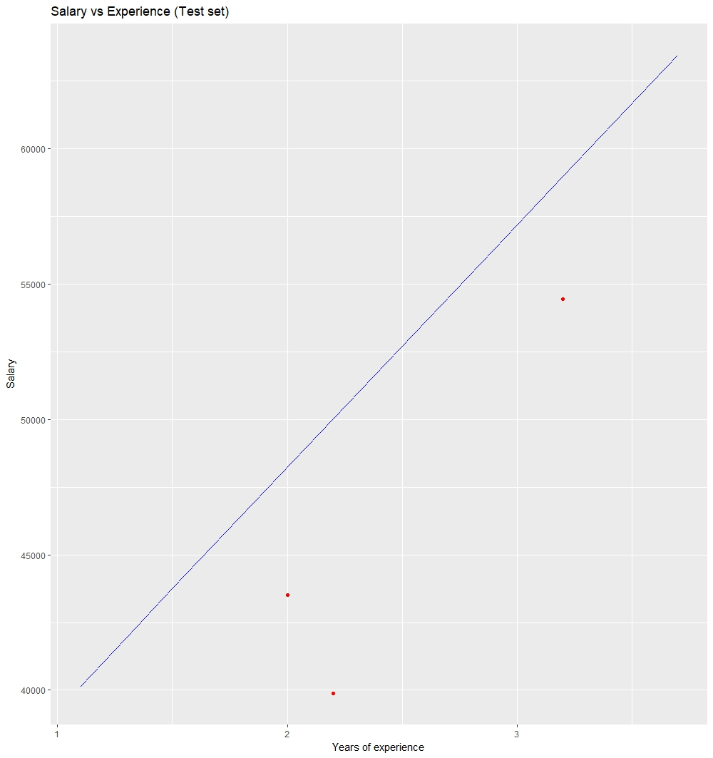

Univariate Linear Regression in Python
Univariate data is the type of data in which the result depends only on one variable. For instance, dataset of points on a line can be considered as a univariate data where abscissa can be considered as input feature and ordinate can be considered as output/result.
For example:
For line Y = 2X + 3;
Input feature will be X and Y will be the result.

X | Y
1 | 5
2 | 7
3 | 9
4 | 11
5 | 13
Concept:
For univariate linear regression, there is only one input feature vector. The line of regression will be in the form of:
Y = b0 + b1 * X
Where,
b0 and b1 are the coefficients of regression.
Hence, it is being tried to predict regression coefficients b0 and b1 by training a model.
Utility functions
- Predict
def predict(x, b0, b1):
"""Predicts the value of prediction based on
current value of regression coefficients when input is x"""
# Y = b0 + b1 * X
return b0 + b1 * x

- Cost function :
Cost function computes the error percentage with the current value of regression coefficients. It quantitatively defines how far the model is wrt actual regression coefficients which has lowest rate of error.
def cost(x, y, b0, b1):
# y is a list of expected value
errors = []
for x, y in zip(x, y):
prediction = predict(x, b0, b1)
expected = y
difference = prediction-expected
errors.append(difference)
# Now, we have errors for all the observations,

# for some input, the value of error might be positive
# and for some input might be negative,
# and if we directly add them up,
# the values might cancel out leading to wrong output."

# Hence, we use concept of mean squared error.
# in mse, we return mean of square of all the errors.
mse = sum([e * e for e in errors])/len(errors)
return mse

- Cost Derivative
After each iteration, the cost is upgraded in proportion to the error. The nature of error is very data sensitive. By data-sensitive i mean the error value changes very fast because we had square in error function. Hence, to make it more tolerant to high values of errors, we derivate the error function.
The mathematics is as follows:
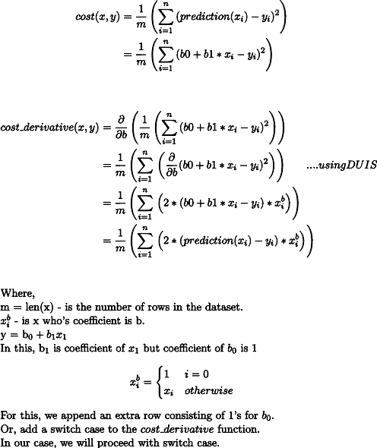
Code:
def cost_derivative(x, y, b0, b1, i):
return sum([
2*(predict(xi, b0, b1)-yi)*1
if i == 0
else 2*(predict(xi, b0, b1)-yi)*xi
for xi, yi in zip(x, y)
])/len(x)

- Update Coefficients :
At each iteration (epoch), the values of the regression coefficient are updated by a specific value wrt to the error from the previous iteration. This updation is very crucial and is the crux of the machine learning applications that you write.
Updating the coefficients with exact an update of a coefficient is done by penalizing its value with a fraction of error that its previous values caused.
This fraction is called as learning rate. This defines how fast our model reaches out to point of convergence(point where error is ideally 0).
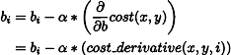
Python function for the same is as follows:
def update_coeff(x, y, b0, b1, i, alpha):
bi -= alpha * cost_derivative(x, y, b0, b1, i)
return bi

- Stop Iterations:
This is the function that is used to specify when should the iterations should stop.
As per user, the algorithm stop_iteration generally returns true in following conditions:
  - Max Iteration : Model is trained for a specified number of iterations.
  - Error value : Depending upon the value of previous error, the algorithm decides whether to continue or stop.
  - Accuracy : Depending upon the last accuracy of the model, if it is larger than the mentioned accuracy, the algorithm returns True,
  - Hybrid : This is more often used. This combines more than one above mentioned conditions along with an exceptional break option. Exceptional break is condition where training continues until when something bad happens. Something bad might include overflow of result, time constraints exceeded, etc.
Having all the utility functions defined, lets see the pseudo code followed by its implementation:
Code :
x, y is the given data.
(b0, b1) <-- (0, 0)
i = 0
while True:
if stop_iteration(i):
break
else:
b0 = update_coeff(x, y, b0, b1, 0, alpha)
b1 = update_coeff(x, y, b0, b1, 1, alpha)

Final Oop implementation :
class LinearRegressor:
def __init__(self, x, y, alpha = 0.01, b0 = 0, b1 = 0):
"""
x: input feature
y: result / target
alpha: learning rate, default is 0.01
b0, b1: linear regression coefficient.
"""
self.i = 0
self.x = x
self.y = y
self.alpha = alpha
self.b0 = b0
self.b1 = b1
if len(x) != len(y):
raise TypeError("x and y should have same number of rows.")

def predict(model, x):
"""Predicts the value of prediction based on
current value of regression coefficients when input is x"""
# Y = b0 + b1 * X
return model.b0 + model.b1 * x

def cost_derivative(model, i):
x, y, b0, b1 = model.x, model.y, model.b0, model.b1
predict = model.predict
return sum([
2 * (predict(xi) - yi) * 1
if i == 0
else (predict(xi) - yi) * xi
for xi, yi in zip(x, y)
]) / len(x)

def update_coeff(model, i):
cost_derivative = model.cost_derivative
if i == 0:
model.b0 -= model.alpha * cost_derivative(i)
elif i == 1:
model.b1 -= model.alpha * cost_derivative(i)

def stop_iteration(model, max_epochs = 1000):
model.i += 1
if model.i == max_epochs:
return True
else:
return False

def fit(model):
update_coeff = model.update_coeff
model.i = 0
while True:
if model.stop_iteration():
break
else:
update_coeff(0)
update_coeff(1)

if __name__ == '__main__':
linearRegressor = LinearRegressor(
x =[i for i in range(12)],
y =[2 * i + 3 for i in range(12)],
alpha = 0.03
)
linearRegressor.fit()
print(linearRegressor.predict(12))

# expects 2 * 12 + 3 = 27

ML | Multiple Linear Regression using Python
Linear Regression:

It is the basic and commonly used type for predictive analysis. It is a statistical approach to modeling the relationship between a dependent variable and a given set of independent variables.
These are of two types:
- Simple linear Regression
- Multiple Linear Regression
Let’s Discuss Multiple Linear Regression using Python.
Multiple Linear Regression attempts to model the relationship between two or more features and a response by fitting a linear equation to observed data. The steps to perform multiple linear Regression are almost similar to that of simple linear Regression. The Difference Lies in the evaluation. We can use it to find out which factor has the highest impact on the predicted output and now different variables relate to each other.
Here : Y = b0 + b1 * x1 + b2 * x2 + b3 * x3 + …… bn * xn
Y = Dependent variable and x1, x2, x3, …… xn = multiple independent variables
Assumption of Regression Model :
- Linearity: The relationship between dependent and independent variables should be linear.
- Homoscedasticity: Constant variance of the errors should be maintained.
- Multivariate normality: Multiple Regression assumes that the residuals are normally distributed.
- Lack of Multicollinearity: It is assumed that there is little or no multicollinearity in the data.
Dummy Variable:
As we know in the Multiple Regression Model we use a lot of categorical data. Using Categorical Data is a good method to include non-numeric data into the respective Regression Model. Categorical Data refers to data values that represent categories-data values with the fixed and unordered number of values, for instance, gender(male/female). In the regression model, these values can be represented by Dummy Variables.
These variables consist of values such as 0 or 1 representing the presence and absence of categorical values.
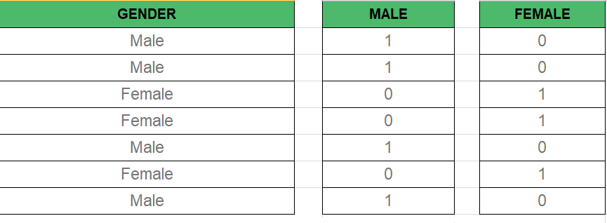
Dummy Variable Trap:
The Dummy Variable Trap is a condition in which two or more are Highly Correlated. In the simple term, we can say that one variable can be predicted from the prediction of the other. The solution of the Dummy Variable Trap is to drop one of the categorical variables. So if there are m Dummy variables then m-1 variables are used in the model.
D2 = D1-1
Here D2, D1 = Dummy Variables

Method of Building Models :
- All-in
- Backward-Elimination
- Forward Selection
- Bidirectional Elimination
- Score Comparison

Backward-Elimination :
Step #1: Select a significant level to start in the model.
Step #2: Fit the full model with all possible predictors.
Step #3: Consider the predictor with the highest P-value. If P > SL go to STEP 4, otherwise the model is Ready.
Step #4: Remove the predictor.
Step #5: Fit the model without this variable.

Forward-Selection :
Step #1 : Select a significance level to enter the model(e.g. SL = 0.05)
Step #2: Fit all simple regression models y~ x(n). Select the one with the lowest P-value.
Step #3: Keep this variable and fit all possible models with one extra predictor added to the one(s) you already have.
Step #4: Consider the predictor with the lowest P-value. If P < SL, go to Step #3, otherwise the model is Ready.

Steps Involved in any Multiple Linear Regression Model
Step #1: Data Pre Processing
- Importing The Libraries.
- Importing the Data Set.
- Encoding the Categorical Data.
- Avoiding the Dummy Variable Trap.
- Splitting the Data set into Training Set and Test Set.
Step #2: Fitting Multiple Linear Regression to the Training set
Step #3: Predicting the Test set results.
Code 1 :

import numpy as np
import matplotlib as mpl
from mpl_toolkits.mplot3d import Axes3D
import matplotlib.pyplot as plt

def generate_dataset(n):
x = []
y = []
random_x1 = np.random.rand()
random_x2 = np.random.rand()
for i in range(n):
x1 = i
x2 = i/2 + np.random.rand()*n
x.append([1, x1, x2])
y.append(random_x1 * x1 + random_x2 * x2 + 1)
return np.array(x), np.array(y)

x, y = generate_dataset(200)

mpl.rcParams['legend.fontsize'] = 12

fig = plt.figure()
ax = fig.gca(projection ='3d')

ax.scatter(x[:, 1], x[:, 2], y, label ='y', s = 5)
ax.legend()
ax.view_init(45, 0)

plt.show()

Output:
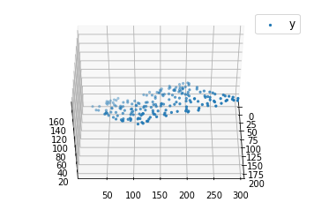
Code 2:

def mse(coef, x, y):
return np.mean((np.dot(x, coef) - y)**2)/2

def gradients(coef, x, y):
return np.mean(x.transpose()*(np.dot(x, coef) - y), axis = 1)

def multilinear_regression(coef, x, y, lr, b1 = 0.9, b2 = 0.999, epsilon = 1e-8):
prev_error = 0
m_coef = np.zeros(coef.shape)
v_coef = np.zeros(coef.shape)
moment_m_coef = np.zeros(coef.shape)
moment_v_coef = np.zeros(coef.shape)
t = 0

while True:
error = mse(coef, x, y)
if abs(error - prev_error) <= epsilon:
break
prev_error = error
grad = gradients(coef, x, y)
t += 1
m_coef = b1 * m_coef + (1-b1)*grad
v_coef = b2 * v_coef + (1-b2)*grad**2
moment_m_coef = m_coef / (1-b1**t)
moment_v_coef = v_coef / (1-b2**t)

delta = ((lr / moment_v_coef**0.5 + 1e-8) *
(b1 * moment_m_coef + (1-b1)*grad/(1-b1**t)))

coef = np.subtract(coef, delta)
return coef

coef = np.array([0, 0, 0])
c = multilinear_regression(coef, x, y, 1e-1)
fig = plt.figure()
ax = fig.gca(projection ='3d')

ax.scatter(x[:, 1], x[:, 2], y, label ='y',
s = 5, color ="dodgerblue")

ax.scatter(x[:, 1], x[:, 2], c[0] + c[1]*x[:, 1] + c[2]*x[:, 2],
label ='regression', s = 5, color ="orange")

ax.view_init(45, 0)
ax.legend()
plt.show()

Output:
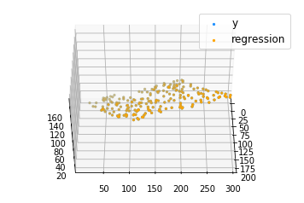

Multiple Linear Regression using R
Prerequisite: Simple Linear-Regression using R
Linear Regression:
It is the basic and commonly used type for predictive analysis. It is a statistical approach for modeling the relationship between a dependent variable and a given set of independent variables.
These are of two types:

- Simple linear Regression
- Multiple Linear Regression
Let’s Discuss Multiple Linear Regression using R.
Multiple Linear Regression :
It is the most common form of Linear Regression. Multiple Linear Regression basically describes how a single response variable Y depends linearly on a number of predictor variables.
The basic examples where Multiple Regression can be used are as follows:
- The selling price of a house can depend on the desirability of the location, the number of bedrooms, the number of bathrooms, the year the house was built, the square footage of the lot, and a number of other factors.
- The height of a child can depend on the height of the mother, the height of the father, nutrition, and environmental factors.
Estimation of the Model Parameters
Consider a multiple linear Regression model with k independent predictor variable x1, x2……, xk, and one response variable y.
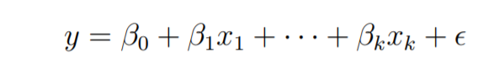
Suppose we have n observation on the k+1 variables and the variable of n should be greater than k.
The basic goal in least-squares regression is to fit a hyper-plane into (k + 1)-dimensional space that minimizes the sum of squared residuals.
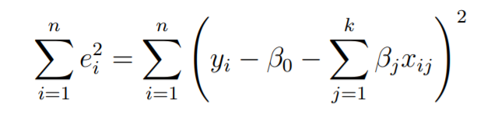
Before taking the derivative with respect to the model parameters set them equal to zero and derive the least-squares normal equations that the parameters would have to fulfill.
These equations are formulated with the help of vectors and matrices.
Let
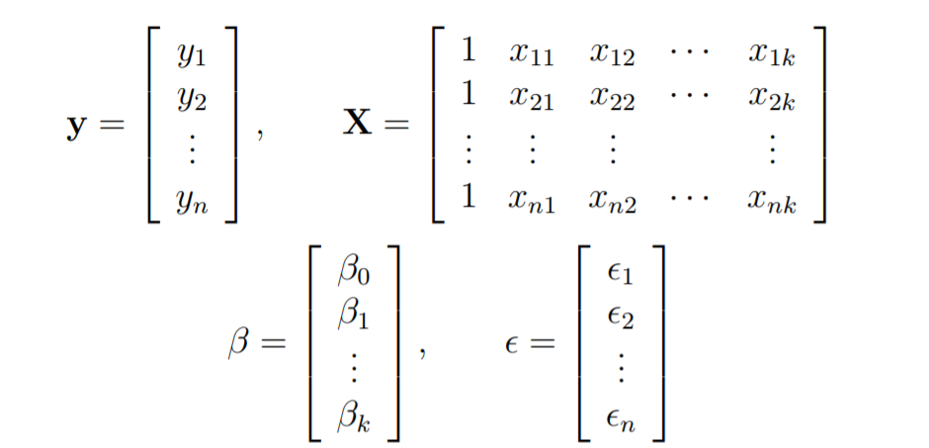
The linear Regression model is written in the form as follows:
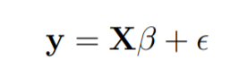
In linear regression the least square parameters estimate b
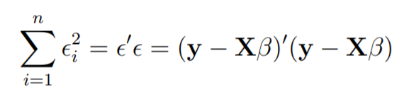
Imagine the columns of X to be fixed, they are the data for a specific problem and say b to be variable. We want to find the “best” b in the sense that the sum of squared residuals is minimized.
The smallest that the sum of squares could be is zero.
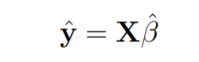
Here y is the estimated response vector.
Following R code is used to implement Multiple Linear Regression on following dataset data2.
the dataset looks like this:
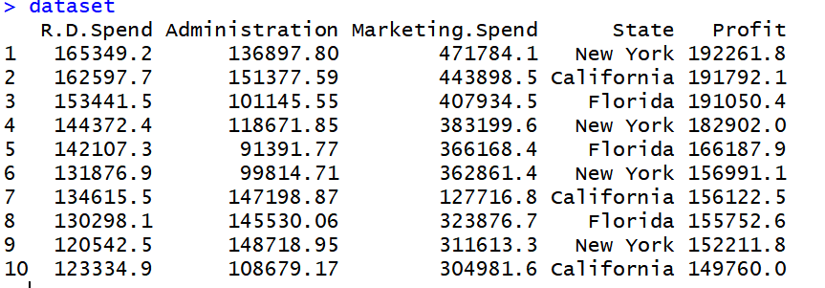

# Multiple Linear Regression

# Importing the dataset
dataset = read.csv('data2.csv')

# Encoding categorical data
dataset$State = factor(dataset$State,
levels = c('New York', 'California', 'Florida'),
labels = c(1, 2, 3))
dataset$State

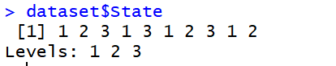

# Splitting the dataset into the Training set and Test set
# install.packages('caTools')
library(caTools)
set.seed(123)
split = sample.split(dataset$Profit, SplitRatio = 0.8)
training_set = subset(dataset, split == TRUE)
test_set = subset(dataset, split == FALSE)

# Feature Scaling
# training_set = scale(training_set)
# test_set = scale(test_set)

# Fitting Multiple Linear Regression to the Training set
regressor = lm(formula = Profit ~ .,
data = training_set)

# Predicting the Test set results
y_pred = predict(regressor, newdata = test_set)

Output:
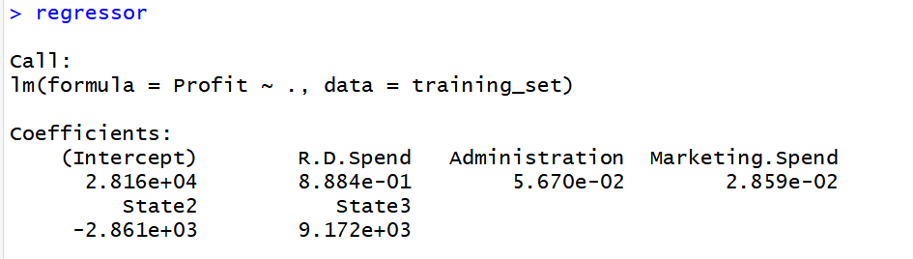

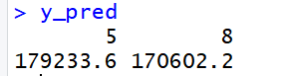

ML | Locally weighted Linear Regression
Prerequisite: ML | Linear Regression

Linear regression is a supervised learning algorithm used for computing linear relationships between input (X) and output (Y).
The steps involved in ordinary linear regression are:
Training phase: Compute to minimize the cost.
Predict output: for given query point ,
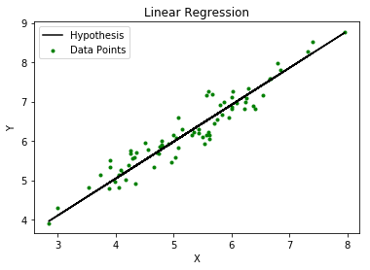
As evident from the image below, this algorithm cannot be used for making predictions when there exists a non-linear relationship between X and Y. In such cases, locally weighted linear regression is used.
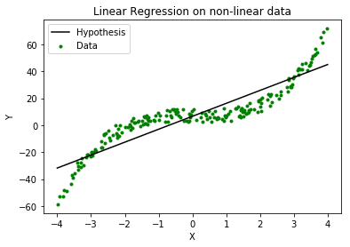

Locally Weighted Linear Regression:
Locally weighted linear regression is a non-parametric algorithm, that is, the model does not learn a fixed set of parameters as is done in ordinary linear regression. Rather parameters are computed individually for each query point . While computing , a higher “preference” is given to the points in the training set lying in the vicinity of than the points lying far away from .
The modified cost function is:
where, is a non-negative “weight” associated with training point .
For s lying closer to the query point , the value of is large, while for s lying far away from the value of is small.
A typical choice of is:
where, is called the bandwidth parameter and controls the rate at which falls with distance from
Clearly, if is small is close to 1 and if is large is close to 0.
Thus, the training-set-points lying closer to the query point contribute more to the cost than the points lying far away from .
For example –
Consider a query point = 5.0 and let and be two points in the training set such that = 4.9 and = 3.0.
Using the formula with = 0.5:
Thus, the weights fall exponentially as the distance between and increases and so does the contribution of error in prediction for to the cost.
Consequently, while computing , we focus more on reducing for the points lying closer to the query point (having larger value of ).
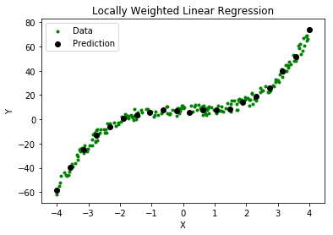
Steps involved in locally weighted linear regression are:
Compute to minimize the cost.
Predict Output: for given query point ,
Points to remember:
- Locally weighted linear regression is a supervised learning algorithm.
- It a non-parametric algorithm.
- There exists No training phase. All the work is done during the testing phase/while making predictions.

Generalized Linear Models
Prerequisite:

- Linear Regression
- Logistic Regression
The following article discusses the Generalized linear models (GLMs) which explains how Linear regression and Logistic regression are a member of a much broader class of models. GLMs can be used to construct the models for regression and classification problems by using the type of distribution which best describes the data or labels given for training the model. Below given are some types of datasets and the corresponding distributions which would help us in constructing the model for a particular type of data (The term data specified here refers to the output data or the labels of the dataset).
- Binary classification data – Bernoulli distribution
- Real valued data – Gaussian distribution
- Count-data – Poisson distribution
To understand GLMs we will begin by defining exponential families. Exponential families are a class of distributions whose probability density function(PDF) can be molded into the following form:
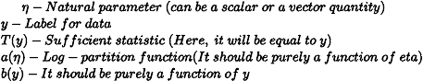
Proof – Bernoulli distribution is a member of the exponential family.
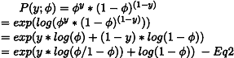
Therefore, on comparing Eq1 and Eq2 :
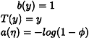
Note: As mentioned above the value of phi (which is the same as the activation or sigmoid function for Logistic regression) is not a coincidence. And it will be proved later in the article how Logistic regression model can be derived from the Bernoulli distribution.
Proof – Gaussian distribution is a member of the exponential family.
Therefore, on comparing Eq1 and Eq3:
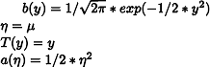
Constructing GLMs:
To construct GLMs for a particular type of data or more generally for linear or logistic classification problems the following three assumptions or design choices are to be considered:
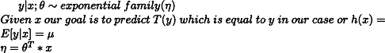
The first assumption is that if x is the input data parameterized by theta the resulting output or y will be a member of the exponential family. This means if we are provided with some labeled data our goal is to find the right parameters theta which fits the given model as closely as possible. The third assumption is the least justified and can be considered as a design choice.
Linear Regression Model:
To show that Linear Regression is a special case of the GLMs. It is considered that the output labels are continuous values and are therefore a Gaussian distribution. So, we have
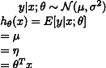
The first equation above corresponds to the first assumption that the output labels (or target variables) should be the member of an exponential family, Second equation corresponds to the assumption that the hypothesis is equal the expected value or mean of the distribution and lastly, the third equation corresponds to the assumption that natural parameter and the input parameters follow a linear relationship.
Logistic Regression Model:
To show that Logistic Regression is a special case of the GLMs. It is considered that the output labels are Binary valued and are therefore a Bernoulli distribution. So, we have
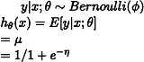
From the third assumption, it is proven that:
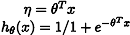
The function that maps the natural parameter to the canonical parameter is known as the canonical response function (here, the log-partition function) and the inverse of it is known as the canonical link function.
Therefore by using the three assumptions mentioned before it can be proved that the Logistic and Linear Regression belongs to a much larger family of models known as GLMs.
Reference: http://cs229.stanford.edu/notes/cs229-notes1.pdf

Python | Linear Regression using sklearn
Prerequisite: Linear Regression Linear Regression is a machine learning algorithm based on supervised learning. It performs a regression task. Regression models a target prediction value based on independent variables. It is mostly used for finding out the relationship between variables and forecasting. Different regression models differ based on – the kind of relationship between dependent and independent variables, they are considering and the number of independent variables being used. This article is going to demonstrate how to use the various Python libraries to implement linear regression on a given dataset. We will demonstrate a binary linear model as this will be easier to visualize. In this demonstration, the model will use Gradient Descent to learn. You can learn about it here.

Step 1: Importing all the required libraries

import numpy as np
import pandas as pd
import seaborn as sns
import matplotlib.pyplot as plt
from sklearn import preprocessing, svm
from sklearn.model_selection import train_test_split
from sklearn.linear_model import LinearRegression

Step 2: Reading the dataset You can download the dataset

df = pd.read_csv('bottle.csv')
df_binary = df[['Salnty', 'T_degC']]

# Taking only the selected two attributes from the dataset
df_binary.columns = ['Sal', 'Temp']
#display the first 5 rows
df_binary.head()

Output:
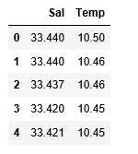
Step 3: Exploring the data scatter

#plotting the Scatter plot to check relationship between Sal and Temp
sns.lmplot(x ="Sal", y ="Temp", data = df_binary, order = 2, ci = None)

Output:
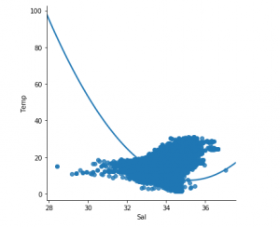
Step 4: Data cleaning

# Eliminating NaN or missing input numbers
df_binary.fillna(method ='ffill', inplace = True)

Step 5: Training our model

X = np.array(df_binary['Sal']).reshape(-1, 1)
y = np.array(df_binary['Temp']).reshape(-1, 1)

# Separating the data into independent and dependent variables
# Converting each dataframe into a numpy array
# since each dataframe contains only one column
df_binary.dropna(inplace = True)

# Dropping any rows with Nan values
X_train, X_test, y_train, y_test = train_test_split(X, y, test_size = 0.25)

# Splitting the data into training and testing data
regr = LinearRegression()

regr.fit(X_train, y_train)
print(regr.score(X_test, y_test))

Output:
Step 6: Exploring our results

y_pred = regr.predict(X_test)
plt.scatter(X_test, y_test, color ='b')
plt.plot(X_test, y_pred, color ='k')

plt.show()
# Data scatter of predicted values

Output:
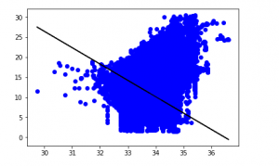
The low accuracy score of our model suggests that our regressive model has not fit very well with the existing data. This suggests that our data is not suitable for linear regression. But sometimes, a dataset may accept a linear regressor if we consider only a part of it. Let us check for that possibility.
Step 7: Working with a smaller dataset

df_binary500 = df_binary[:][:500]

# Selecting the 1st 500 rows of the data
sns.lmplot(x ="Sal", y ="Temp", data = df_binary500,
order = 2, ci = None)

Output:
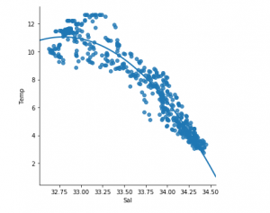
We can already see that the first 500 rows follow a linear model. Continuing with the same steps as before.

df_binary500.fillna(method ='ffill', inplace = True)

X = np.array(df_binary500['Sal']).reshape(-1, 1)
y = np.array(df_binary500['Temp']).reshape(-1, 1)

df_binary500.dropna(inplace = True)
X_train, X_test, y_train, y_test = train_test_split(X, y, test_size = 0.25)

regr = LinearRegression()
regr.fit(X_train, y_train)
print(regr.score(X_test, y_test))

Output:
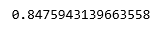

y_pred = regr.predict(X_test)
plt.scatter(X_test, y_test, color ='b')
plt.plot(X_test, y_pred, color ='k')

plt.show()

Output:
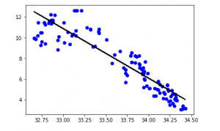
Step 8: Evaluation Metrics For Regression
At last, we check the performance of the Linear Regression model with help of evaluation metrics. For Regression algorithms we widely use mean_absolute_error, and mean_squared_error metrics to check the model performance.

from sklearn.metrics import mean_absolute_error,mean_squared_error

mae = mean_absolute_error(y_true=y_test,y_pred=y_pred)
#squared True returns MSE value, False returns RMSE value.
mse = mean_squared_error(y_true=y_test,y_pred=y_pred) #default=True
rmse = mean_squared_error(y_true=y_test,y_pred=y_pred,squared=False)

print("MAE:",mae)
print("MSE:",mse)
print("RMSE:",rmse)

Output:
MAE: 0.7927322046360309
MSE: 1.0251137190180517
RMSE: 1.0124789968281078

Linear Regression Using Tensorflow

Prerequisites
We will briefly summarize Linear Regression before implementing it using Tensorflow. Since we will not get into the details of either Linear Regression or Tensorflow, please read the following articles for more details:

- Linear Regression (Python Implementation)
- Introduction to TensorFlow
- Introduction to Tensor with Tensorflow

Brief Summary of Linear Regression
Linear Regression is a very common statistical method that allows us to learn a function or relationship from a given set of continuous data. For example, we are given some data points of x and corresponding y and we need to learn the relationship between them that is called a hypothesis.
In case of Linear regression, the hypothesis is a straight line, i.e,
Where w is a vector called Weights and b is a scalar called Bias. The Weights and Bias are called the parameters of the model.
All we need to do is estimate the value of w and b from the given set of data such that the resultant hypothesis produces the least cost J which is defined by the following cost function
where m is the number of data points in the given dataset. This cost function is also called Mean Squared Error.
For finding the optimized value of the parameters for which J is minimum, we will be using a commonly used optimizer algorithm called Gradient Descent. Following is the pseudo-code for Gradient Descent:
Repeat untill Convergence {
w = w - α * δJ/δw
b = b - α * δJ/δb
}
where α is a hyperparameter called the Learning Rate.

Tensorflow
Tensorflow is an open-source computation library made by Google. It is a popular choice for creating applications that require high-end numerical computations and/or need to utilize Graphics Processing Units for computation purposes. These are the main reasons due to which Tensorflow is one of the most popular choices for Machine Learning applications, especially Deep Learning. It also has APIs like Estimator which provide a high level of abstraction while building Machine Learning Applications. In this article, we will not be using any high-level APIs, rather we will be building the Linear Regression model using low-level Tensorflow in the Lazy Execution Mode during which Tensorflow creates a Directed Acyclic Graph or DAG which keeps track of all the computations, and then executes all the computations done inside a Tensorflow Session.

Implementation
We will start by importing the necessary libraries. We will use Numpy along with Tensorflow for computations and Matplotlib for plotting.

import numpy as np
import tensorflow as tf
import matplotlib.pyplot as plt

In order to make the random numbers predictable, we will define fixed seeds for both Numpy and Tensorflow.

np.random.seed(101)
tf.set_random_seed(101)

Now, let us generate some random data for training the Linear Regression Model.

# Generating random linear data
# There will be 50 data points ranging from 0 to 50
x = np.linspace(0, 50, 50)
y = np.linspace(0, 50, 50)

# Adding noise to the random linear data
x += np.random.uniform(-4, 4, 50)
y += np.random.uniform(-4, 4, 50)

n = len(x) # Number of data points

Let us visualize the training data.

# Plot of Training Data
plt.scatter(x, y)
plt.xlabel('x')
plt.ylabel('y')
plt.title("Training Data")
plt.show()

Output:
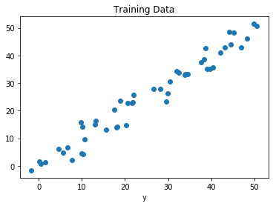
Now we will start creating our model by defining the placeholders X and Y, so that we can feed our training examples X and Y into the optimizer during the training process.

X = tf.placeholder("float")
Y = tf.placeholder("float")

Now we will declare two trainable Tensorflow Variables for the Weights and Bias and initializing them randomly using np.random.randn().

W = tf.Variable(np.random.randn(), name = "W")
b = tf.Variable(np.random.randn(), name = "b")

Now we will define the hyperparameters of the model, the Learning Rate and the number of Epochs.

learning_rate = 0.01
training_epochs = 1000

Now, we will be building the Hypothesis, the Cost Function, and the Optimizer. We won’t be implementing the Gradient Descent Optimizer manually since it is built inside Tensorflow. After that, we will be initializing the Variables.

# Hypothesis
y_pred = tf.add(tf.multiply(X, W), b)

# Mean Squared Error Cost Function
cost = tf.reduce_sum(tf.pow(y_pred-Y, 2)) / (2 * n)

# Gradient Descent Optimizer
optimizer = tf.train.GradientDescentOptimizer(learning_rate).minimize(cost)

# Global Variables Initializer
init = tf.global_variables_initializer()

Now we will begin the training process inside a Tensorflow Session.

# Starting the Tensorflow Session
with tf.Session() as sess:

# Initializing the Variables
sess.run(init)

# Iterating through all the epochs
for epoch in range(training_epochs):

# Feeding each data point into the optimizer using Feed Dictionary
for (_x, _y) in zip(x, y):
sess.run(optimizer, feed_dict = {X : _x, Y : _y})

# Displaying the result after every 50 epochs
if (epoch + 1) % 50 == 0:
# Calculating the cost a every epoch
c = sess.run(cost, feed_dict = {X : x, Y : y})
print("Epoch", (epoch + 1), ": cost =", c, "W =", sess.run(W), "b =", sess.run(b))

# Storing necessary values to be used outside the Session
training_cost = sess.run(cost, feed_dict ={X: x, Y: y})
weight = sess.run(W)
bias = sess.run(b)

Output:
Epoch: 50 cost = 5.8868036 W = 0.9951241 b = 1.2381054
Epoch: 100 cost = 5.7912707 W = 0.99812365 b = 1.0914398
Epoch: 150 cost = 5.7119675 W = 1.0008028 b = 0.96044314
Epoch: 200 cost = 5.6459413 W = 1.0031956 b = 0.8434396
Epoch: 250 cost = 5.590799 W = 1.0053328 b = 0.7389357
Epoch: 300 cost = 5.544608 W = 1.007242 b = 0.6455922
Epoch: 350 cost = 5.5057883 W = 1.008947 b = 0.56222
Epoch: 400 cost = 5.473066 W = 1.01047 b = 0.48775345
Epoch: 450 cost = 5.4453845 W = 1.0118302 b = 0.42124167
Epoch: 500 cost = 5.421903 W = 1.0130452 b = 0.36183488
Epoch: 550 cost = 5.4019217 W = 1.0141305 b = 0.30877414
Epoch: 600 cost = 5.3848577 W = 1.0150996 b = 0.26138115
Epoch: 650 cost = 5.370246 W = 1.0159653 b = 0.21905091
Epoch: 700 cost = 5.3576994 W = 1.0167387 b = 0.18124212
Epoch: 750 cost = 5.3468933 W = 1.0174294 b = 0.14747244
Epoch: 800 cost = 5.3375573 W = 1.0180461 b = 0.11730931
Epoch: 850 cost = 5.3294764 W = 1.0185971 b = 0.090368524
Epoch: 900 cost = 5.322459 W = 1.0190892 b = 0.0663058
Epoch: 950 cost = 5.3163586 W = 1.0195289 b = 0.044813324
Epoch: 1000 cost = 5.3110332 W = 1.0199214 b = 0.02561663
Now let us look at the result.

# Calculating the predictions
predictions = weight * x + bias
print("Training cost =", training_cost, "Weight =", weight, "bias =", bias, '\n')

Output:
Training cost = 5.3110332 Weight = 1.0199214 bias = 0.02561663
Note that in this case both the Weight and bias are scalars. This is because, we have considered only one dependent variable in our training data. If we have m dependent variables in our training dataset, the Weight will be an m-dimensional vector while bias will be a scalar.
Finally, we will plot our result.

# Plotting the Results
plt.plot(x, y, 'ro', label ='Original data')
plt.plot(x, predictions, label ='Fitted line')
plt.title('Linear Regression Result')
plt.legend()
plt.show()

Output:
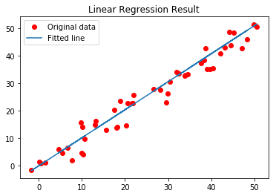

A Practical approach to Simple Linear Regression using R
Simple Linear Regression is a statistical method that allows us to summarize and study relationships between two continuous (quantitative) variables. One variable denoted x is regarded as an independent variable and other one denoted y is regarded as a dependent variable. It is assumed that the two variables are linearly related. Hence, we try to find a linear function that predicts the response value (y) as accurately as possible as a function of the feature or independent variable (x).

The simplest form of the regression equation with one dependent and one independent variable is defined by the formula:
y = c + b * x
where:
y = estimated dependent variable score,
c = constant, b = regression coefficient, and
x = score on the independent variable.
Dependent Variable is also called as outcome variable, criterion variable, endogenous variable, or regressand.
Independent Variable is also called as exogenous variables, predictor variables, or regressors.
The overall idea of regression is to examine two things –
- Does a set of predictor variables do a good job in predicting an outcome (dependent) variable?
- Which variables, in particular, are significant predictors of the outcome variable, and in what way do they–indicated by the magnitude and sign of the beta estimates–impact the outcome variable?
These simple linear regression estimates are used to explain the relationship between one dependent variable and one independent variable.
Now, here we would implement the linear regression approach to one of our datasets. The dataset that we are using here is the salary dataset of some organization that decides its salary based on the number of years the employee has worked in the organization. So, we need to find out if there is any relation between the number of years the employee has worked and the salary he/she gets. Then we are going to test that the model that we have made on the training dataset is working fine with the test dataset or not.
Step #1:
The first thing that you need to do is to download the dataset from here.
Save the downloaded dataset in your system so that it is easy to fetch when required.
Step #2:
The next is to open the R studio since we are going to implement the regression in the R environment.
Step #3: Now in this step we are going to deal with the whole operation that we are going to perform in the R studio. Commands with their brief explanation are as follows –
Loading the Dataset –
The first step is to set the working directory. Working directory means the directory in which you are currently working. setwd() is used to set the working directory.
setwd("C:/Users/hp/Desktop")
Now we are going to load the dataset to the R studio. In this case, we have a CSV (comma separated values) file, so we are going to use the read.csv() to load the Salary_Data.csv dataset to the R environment. Also, we are going to assign the dataset to a variable and here suppose let’s take the name of the variable to be as raw_data.
raw_data <- read.csv("Salary_Data.csv")

Now, to view the dataset on the R studio, use name of the variable to which we have loaded the dataset in the previous step.
raw_data
Step #4: Splitting the Dataset.
Now we are going to split the dataset into the training dataset and the test dataset.
Training data, also called AI training data, training set, training dataset, or learning set — is the information used to train an algorithm. The training data includes both input data and the corresponding expected output. Based on this “ground truth” data, the algorithm can learn how to apply technologies such as neural networks, to learn and produce complex results, so that it can make accurate decisions when later presented with new data.
Testing data, on the other hand, includes only input data, not the corresponding expected output. The testing data is used to assess how well your algorithm was trained, and to estimate model properties.
For doing the splitting, we need to install the caTools package and import the caTools library.
install.packages('caTools')
library(caTools)
Now, we will set the seed. When we will split the whole dataset into the training dataset and the test dataset, then this seed will enable us to make the same partitions in the datasets.
set.seed(123)
Now, after setting the seed, we will finally split the dataset. In general, it is recommended to split the dataset in the ratio of 3:1. That is 75% of the original dataset would be our training dataset and 25% of the original dataset would be our test dataset. But, here in this dataset, we are having only 30 rows. So, it is more appropriate to allow 20 rows(i.e. 2/3 part) to the training dataset and 10 rows(i.e. 1/3 part) to the test dataset.
split = sample.split(raw_data$Salary, SplitRatio = 2/3)
Here sample.split() is the function that splits the original dataset. The first argument of this function denotes on the basis of which column we want to split our dataset. Here, we have done the splitting on the basis of Salary column. SplitRatio specifies the part that would be allocated to the training dataset.
Now, the subset with the split = TRUE will be assigned to the training dataset and the subset with the split = FALSE will be assigned to the test dataset.
training_set <- subset(raw_data, split == TRUE)
test_set <- subset(raw_data, split == FALSE)
Step #5: Fitting the Linear Simple Regression to the Training Dataset.
Now, we will make a linear regression model that will fit our training dataset. lm() function is used to do so. lm() is used to fit linear models. It can be used to carry out regression, single stratum analysis of variance, and analysis of covariance.
regressor = lm(formula = Salary ~ YearsExperience, data = training_set)
Basically, there are a number of arguments for the lm() function but here we are not going to use all of them. The first argument specifies the formula that we want to use to set our linear model. Her, we have used Years of Experience as an independent variable to predict the dependent variable that is the Salary. The second argument specifies which dataset we want to feed to the regressor to build our model. We are going to use the training dataset to feed the regressor.
After training our model on the training dataset, it is the time to analyze our model. To do so, write the following command in the R console:
summary(regressor)
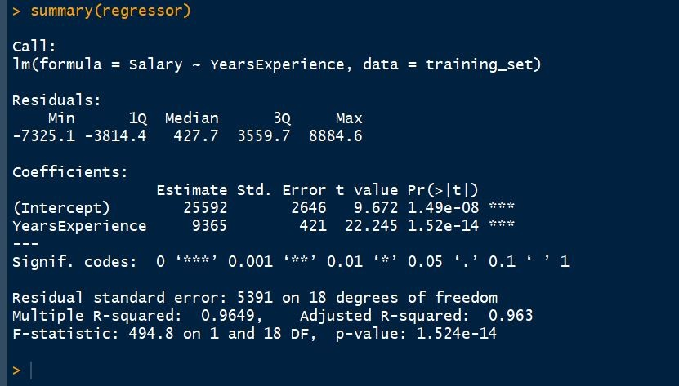
Step #6: Predicting the best set results
Now, it is time to predict the test set results based on the model that we have made on the training dataset. predict() function is used to do so. The first argument we have passed in the function is the model. Here, the model is regressor. The second argument is newdata that specifies which dataset we want to implement our trained model on and predict the results of the new dataset. Here, we have taken the test_set on which we want to implement our model.
y_pred = predict(regressor, newdata = test_set)
Step #7: Visualizing the Training Set results
We are going to visualize the training set results. For doing this we are going to use the ggplot2 library. ggplot2 is a system for declaratively creating graphics, based on The Grammar of Graphics. You provide the data, tell ggplot2 how to map variables to aesthetics, what graphical primitives to use, and it takes care of the details.
library(ggplot2)

ggplot() +
geom_point(aes(x = training_set$YearsExperience,
y = training_set$Salary), colour = 'red') +
geom_line(aes(x = training_set$YearsExperience,
y = predict(regressor, newdata = training_set)),
colour = 'blue') +
ggtitle('Salary vs Experience (Training Set)') +
xlab('Years of Experience') +
ylab('Salary')

Output:
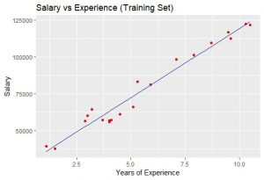
The blue-colored straight line in the graph represents the regressor that we have made from the training dataset. Since we are working with simple linear regression, therefore, the straight line is obtained. Also, the red-colored dots represent the actual training dataset.
Although, we did not accurately predict the results the model that we have trained was close enough to reach accuracy.
Step #8: Visualising the Test Set Results
As we have done for visualizing the training dataset, similarly we can do it to visualize the test dataset also.
library(ggplot2)
ggplot() +
geom_point(aes(x = test_set$YearsExperience,
y = test_set$Salary),
colour = 'red') +
geom_line(aes(x = training_set$YearsExperience,
y = predict(regressor, newdata = training_set)),
colour = 'blue') +
ggtitle('Salary vs Experience (Test Set)') +
xlab('Years of Experience') +
ylab('Salary')

Output:
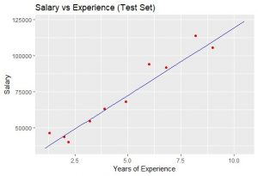
Let's see the complete code for both R and Python -

# Simple Linear Regression

# Importing the dataset
dataset = read.csv('Salary_Data.csv')

# Splitting the dataset into the Training set and Test set
install.packages('caTools')
library(caTools)
set.seed(123)

split = sample.split(dataset$Salary, SplitRatio = 2/3)
training_set = subset(dataset, split == TRUE)
test_set = subset(dataset, split == FALSE)

# Fitting Simple Linear Regression to the Training set
regressor = lm(formula = Salary ~ YearsExperience,
data = training_set)

# Predicting the Test set results
y_pred = predict(regressor, newdata = test_set)

# Visualising the Training set results
library(ggplot2)
ggplot() +
geom_point(aes(x = training_set$YearsExperience,
y = training_set$Salary),
colour = 'red') +
geom_line(aes(x = training_set$YearsExperience,
y = predict(regressor, newdata = training_set)),
colour = 'blue') +
ggtitle('Salary vs Experience (Training set)') +
xlab('Years of experience') +
ylab('Salary')

# Visualising the Test set results
library(ggplot2)
ggplot() +
geom_point(aes(x = test_set$YearsExperience, y = test_set$Salary),
colour = 'red') +
geom_line(aes(x = training_set$YearsExperience,
y = predict(regressor, newdata = training_set)),
colour = 'blue') +
ggtitle('Salary vs Experience (Test set)') +
xlab('Years of experience') +
ylab('Salary')

Linear Regression using PyTorch
Linear Regression is a very commonly used statistical method that allows us to determine and study the relationship between two continuous variables. The various properties of linear regression and its Python implementation have been covered in this article previously. Now, we shall find out how to implement this in PyTorch, a very popular deep learning library that is being developed by Facebook.
Firstly, you will need to install PyTorch into your Python environment. The easiest way to do this is to use the pip or conda tool. Visit pytorch.org and install the version of your Python interpreter and the package manager that you would like to use.

# We can run this Python code on a Jupyter notebook
# to automatically install the correct version of
# PyTorch.

# http://pytorch.org / from os import path
from wheel.pep425tags import get_abbr_impl, get_impl_ver, get_abi_tag
platform = '{}{}-{}'.format(get_abbr_impl(), get_impl_ver(), get_abi_tag())

accelerator = 'cu80' if path.exists('/opt / bin / nvidia-smi') else 'cpu'

! pip install -q http://download.pytorch.org / whl/{accelerator}/torch-1.3.1.post4-{platform}-linux_x86_64.whl torchvision

With PyTorch installed, let us now have a look at the code.
Write the two lines given below to import the necessary library functions and objects.

import torch
from torch.autograd import Variable

We also define some data and assign them to variables x_data and y_data as given below:

x_data = Variable(torch.Tensor([[1.0], [2.0], [3.0]]))
y_data = Variable(torch.Tensor([[2.0], [4.0], [6.0]]))

Here, x_data is our independent variable and y_data is our dependent variable. This will be our dataset for now. Next, we need to define our model. There are two main steps associated with defining our model. They are:
- Initializing our model.
- Declaring the forward pass.
We use the class given below:

class LinearRegressionModel(torch.nn.Module):

def __init__(self):
super(LinearRegressionModel, self).__init__()
self.linear = torch.nn.Linear(1, 1) # One in and one out

def forward(self, x):
y_pred = self.linear(x)
return y_pred

As you can see, our Model class is a subclass of torch.nn.module. Also, since here we have only one input and one output, we use a Linear model with both the input and output dimension as 1.
Next, we create an object of this model.

# our model
our_model = LinearRegressionModel()

After this, we select the optimizer and the loss criteria. Here, we will use the mean squared error (MSE) as our loss function and stochastic gradient descent (SGD) as our optimizer. Also, we arbitrarily fix a learning rate of 0.01.

criterion = torch.nn.MSELoss(size_average = False)
optimizer = torch.optim.SGD(our_model.parameters(), lr = 0.01)

We now arrive at our training step. We perform the following tasks 500 times during training:
- Perform a forward pass bypassing our data and finding out the predicted value of y.
- Compute the loss using MSE.
- Reset all the gradients to 0, perform a backpropagation and then, update the weights.

for epoch in range(500):

# Forward pass: Compute predicted y by passing
# x to the model
pred_y = our_model(x_data)

# Compute and print loss
loss = criterion(pred_y, y_data)

# Zero gradients, perform a backward pass,
# and update the weights.
optimizer.zero_grad()
loss.backward()
optimizer.step()
print('epoch {}, loss {}'.format(epoch, loss.item()))

Once the training is completed, we test if we are getting correct results using the model that we defined. So, we test it for an unknown value of x_data, in this case, 4.0.

new_var = Variable(torch.Tensor([[4.0]]))
pred_y = our_model(new_var)
print("predict (after training)", 4, our_model(new_var).item())

If you performed all steps correctly, you will see that for input 4.0, you are getting a value that is very close to 8.0 as below. So, our model inherently learns the relationship between the input data and the output data without being programmed explicitly.
predict (after training) 4 7.966438293457031
For your reference, you can find the entire code of this article given below:

import torch
from torch.autograd import Variable

x_data = Variable(torch.Tensor([[1.0], [2.0], [3.0]]))
y_data = Variable(torch.Tensor([[2.0], [4.0], [6.0]]))

class LinearRegressionModel(torch.nn.Module):

def __init__(self):
super(LinearRegressionModel, self).__init__()
self.linear = torch.nn.Linear(1, 1) # One in and one out

def forward(self, x):
y_pred = self.linear(x)
return y_pred

# our model
our_model = LinearRegressionModel()

criterion = torch.nn.MSELoss(size_average = False)
optimizer = torch.optim.SGD(our_model.parameters(), lr = 0.01)

for epoch in range(500):

# Forward pass: Compute predicted y by passing
# x to the model
pred_y = our_model(x_data)

# Compute and print loss
loss = criterion(pred_y, y_data)

# Zero gradients, perform a backward pass,
# and update the weights.
optimizer.zero_grad()
loss.backward()
optimizer.step()
print('epoch {}, loss {}'.format(epoch, loss.item()))

new_var = Variable(torch.Tensor([[4.0]]))
pred_y = our_model(new_var)
print("predict (after training)", 4, our_model(new_var).item())

References
- PyTorchZeroToAll
- Penn State STAT 501

Pyspark | Linear regression using Apache MLlib
Problem Statement: Build a predictive Model for the shipping company, to find an estimate of how many Crew members a ship requires.
The dataset contains 159 instances with 9 features.

The Description of dataset is as below:
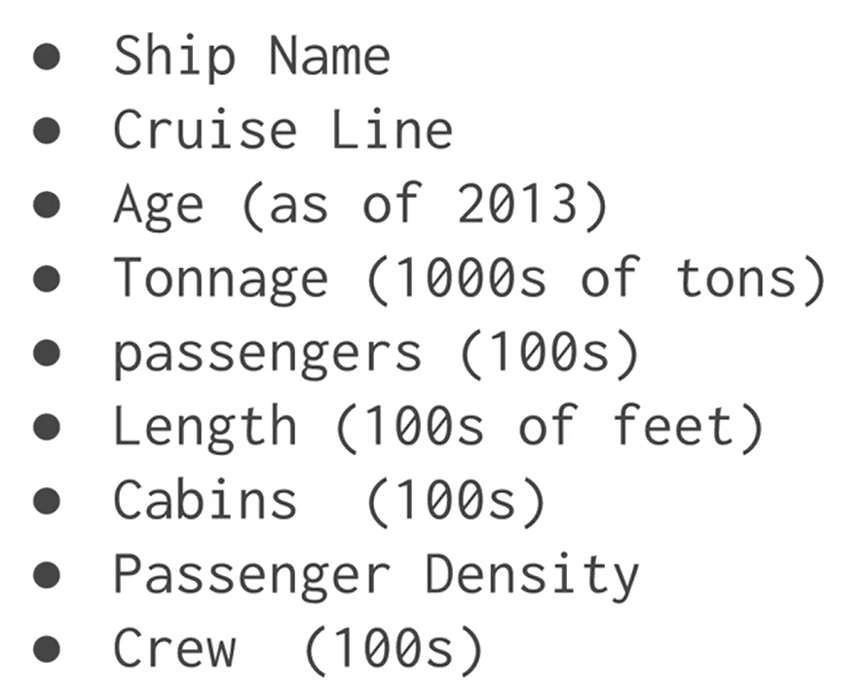
Let’s make the Linear Regression Model, predicting Crew members
Attached dataset: cruise_ship_info
import pyspark
from pyspark.sql import SparkSession
#SparkSession is now the entry point of Spark
#SparkSession can also be construed as gateway to spark libraries

#create instance of spark class
spark=SparkSession.builder.appName('housing_price_model').getOrCreate()

#create spark dataframe of input csv file
df=spark.read.csv('D:\python coding\pyspark_tutorial\Linear regression\cruise_ship_info.csv'
,inferSchema=True,header=True)
df.show(10)

Output :
+-----------+-----------+---+------------------+----------+------+------+-----------------+----+
| Ship_name|Cruise_line|Age| Tonnage|passengers|length|cabins|passenger_density|crew|
+-----------+-----------+---+------------------+----------+------+------+-----------------+----+
| Journey| Azamara| 6|30.276999999999997| 6.94| 5.94| 3.55| 42.64|3.55|
| Quest| Azamara| 6|30.276999999999997| 6.94| 5.94| 3.55| 42.64|3.55|
|Celebration| Carnival| 26| 47.262| 14.86| 7.22| 7.43| 31.8| 6.7|
| Conquest| Carnival| 11| 110.0| 29.74| 9.53| 14.88| 36.99|19.1|
| Destiny| Carnival| 17| 101.353| 26.42| 8.92| 13.21| 38.36|10.0|
| Ecstasy| Carnival| 22| 70.367| 20.52| 8.55| 10.2| 34.29| 9.2|
| Elation| Carnival| 15| 70.367| 20.52| 8.55| 10.2| 34.29| 9.2|
| Fantasy| Carnival| 23| 70.367| 20.56| 8.55| 10.22| 34.23| 9.2|
|Fascination| Carnival| 19| 70.367| 20.52| 8.55| 10.2| 34.29| 9.2|
| Freedom| Carnival| 6|110.23899999999999| 37.0| 9.51| 14.87| 29.79|11.5|
+-----------+-----------+---+------------------+----------+------+------+-----------------+----+
#prints structure of dataframe along with datatype
df.printSchema()

Output :
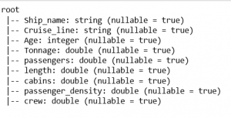
#In our predictive model, below are the columns
df.columns

Output :
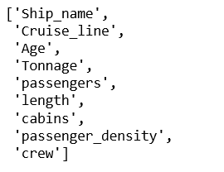
#columns identified as features are as below:
#['Cruise_line','Age','Tonnage','passengers','length','cabins','passenger_density']
#to work on the features, spark MLlib expects every value to be in numeric form
#feature 'Cruise_line is string datatype
#using StringIndexer, string type will be typecast to numeric datatype
#import library strinindexer for typecasting

from pyspark.ml.feature import StringIndexer
indexer=StringIndexer(inputCol='Cruise_line',outputCol='cruise_cat')
indexed=indexer.fit(df).transform(df)

#above code will convert string to numeric feature and create a new dataframe
#new dataframe contains a new feature 'cruise_cat' and can be used further
#feature cruise_cat is now vectorized and can be used to fed to model
for item in indexed.head(5):
print(item)
print('\n')

Output :
Row(Ship_name='Journey', Cruise_line='Azamara', Age=6,
Tonnage=30.276999999999997, passengers=6.94, length=5.94,
cabins=3.55, passenger_density=42.64, crew=3.55, cruise_cat=16.0)

Row(Ship_name='Quest', Cruise_line='Azamara', Age=6,
Tonnage=30.276999999999997, passengers=6.94, length=5.94,
cabins=3.55, passenger_density=42.64, crew=3.55, cruise_cat=16.0)

Row(Ship_name='Celebration', Cruise_line='Carnival', Age=26,
Tonnage=47.262, passengers=14.86, length=7.22,
cabins=7.43, passenger_density=31.8, crew=6.7, cruise_cat=1.0)

Row(Ship_name='Conquest', Cruise_line='Carnival', Age=11,
Tonnage=110.0, passengers=29.74, length=9.53,
cabins=14.88, passenger_density=36.99, crew=19.1, cruise_cat=1.0)

Row(Ship_name='Destiny', Cruise_line='Carnival', Age=17,
Tonnage=101.353, passengers=26.42, length=8.92,
cabins=13.21, passenger_density=38.36, crew=10.0, cruise_cat=1.0)
from pyspark.ml.linalg import Vectors
from pyspark.ml.feature import VectorAssembler
#creating vectors from features
#Apache MLlib takes input if vector form
assembler=VectorAssembler(inputCols=['Age',
'Tonnage',
'passengers',
'length',
'cabins',
'passenger_density',
'cruise_cat'],outputCol='features')
output=assembler.transform(indexed)
output.select('features','crew').show(5)
#output as below

Output :
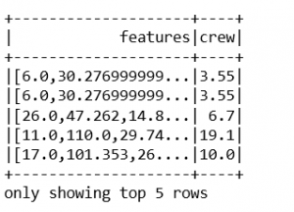
#final data consist of features and label which is crew.
final_data=output.select('features','crew')
#splitting data into train and test
train_data,test_data=final_data.randomSplit([0.7,0.3])
train_data.describe().show()

Output :
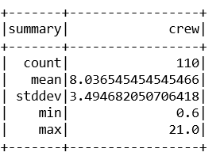
test_data.describe().show()

Output :
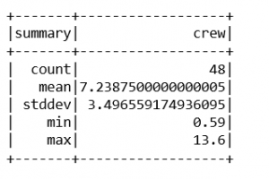
#import LinearRegression library
from pyspark.ml.regression import LinearRegression
#creating an object of class LinearRegression
#object takes features and label as input arguments
ship_lr=LinearRegression(featuresCol='features',labelCol='crew')
#pass train_data to train model
trained_ship_model=ship_lr.fit(train_data)
#evaluating model trained for Rsquared error
ship_results=trained_ship_model.evaluate(train_data)

print('Rsquared Error :',ship_results.r2)
#R2 value shows accuracy of model is 92%
#model accuracy is very good and can be use for predictive analysis

Output :
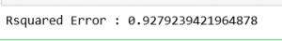
#testing Model on unlabeled data
#create unlabeled data from test_data
#testing model on unlabeled data
unlabeled_data=test_data.select('features')
unlabeled_data.show(5)

Output :
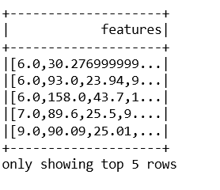
predictions=trained_ship_model.transform(unlabeled_data)
predictions.show()
#below are the results of output from test data

Output :
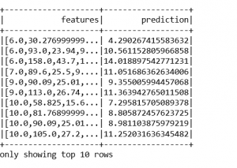
from sklearn.metrics import mean_squared_error, mean_absolute_error
mse = mean_squared_error(ytest, y_pred)
mae = mean_absolute_error(ytest,y_pred)
print("Mean Square Error : ", mse)
print("Mean Absolute Error : ", mae)
Mean Square Error : 33.448979997676496
Mean Absolute Error : 3.8429092204444966
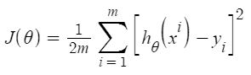
As per the result, our model is only 66.55% accurate. So, the prepared model is not very good for predicting housing prices. One can improve the prediction results using many other possible machine learning algorithms and techniques.
Here are a few further steps on how you can improve your model.
- Feature Selection
- Cross-Validation
- Hyperparameter Tuning

ML | Boston Housing Kaggle Challenge with Linear Regression
Boston Housing Data: This dataset was taken from the StatLib library and is maintained by Carnegie Mellon University. This dataset concerns the housing prices in the housing city of Boston. The dataset provided has 506 instances with 13 features.
The Description of the dataset is taken from the below reference as shown in the table follows:

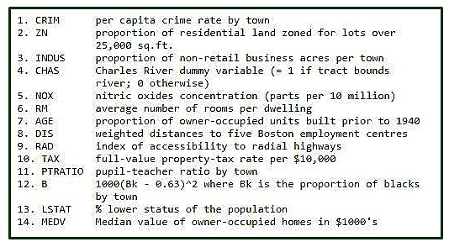
Let’s make the Linear Regression Model, predicting housing prices by Inputting Libraries and datasets.

# Importing Libraries
import numpy as np
import pandas as pd
import matplotlib.pyplot as plt

# Importing Data
from sklearn.datasets import load_boston
boston = load_boston()

The shape of input Boston data and getting feature_names.

boston.data.shape

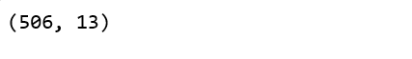

boston.feature_names

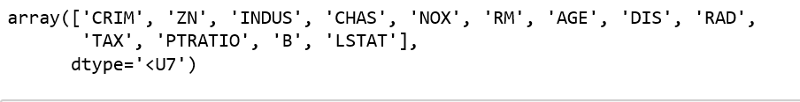
Converting data from nd-array to data frame and adding feature names to the data

data = pd.DataFrame(boston.data)
data.columns = boston.feature_names

data.head(10)

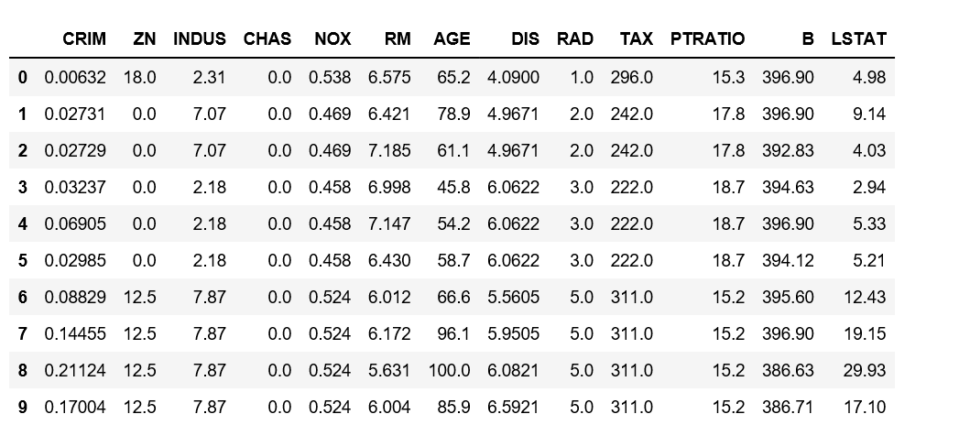
Adding the ‘Price’ column to the dataset

# Adding 'Price' (target) column to the data
boston.target.shape

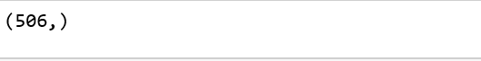

data['Price'] = boston.target
data.head()

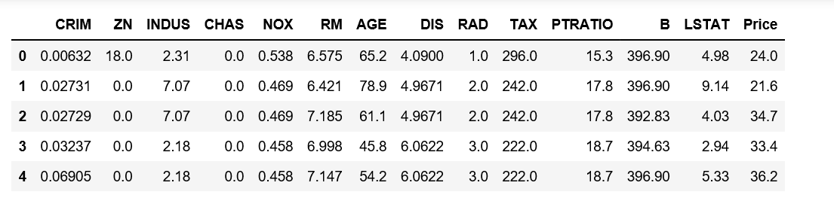
Description of Boston dataset

data.describe()

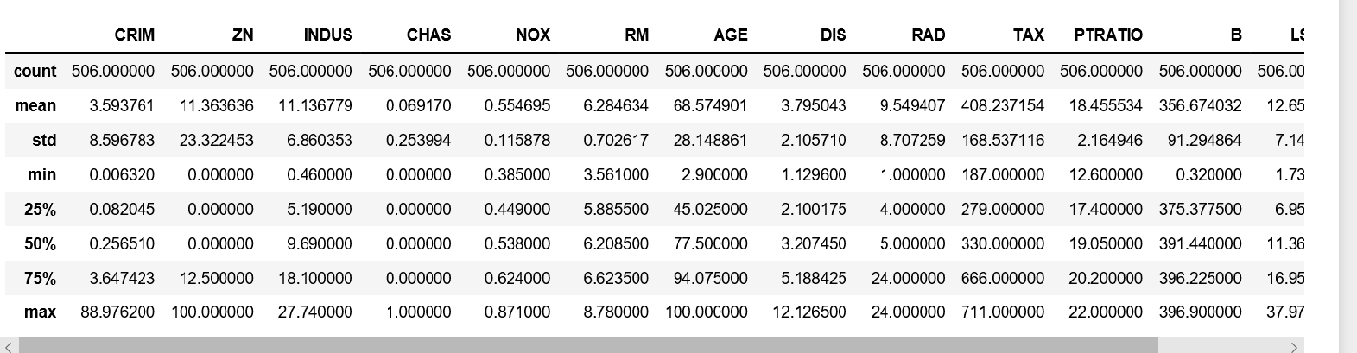
Info of Boston Dataset

data.info()

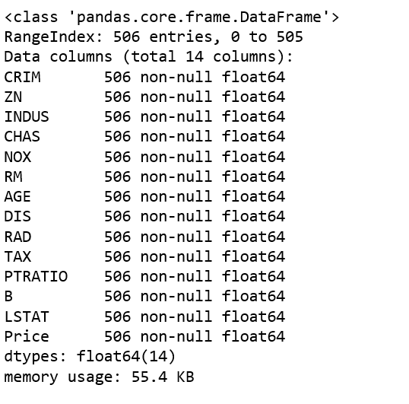
Getting input and output data and further splitting data to training and testing dataset.

# Input Data
x = boston.data

# Output Data
y = boston.target

# splitting data to training and testing dataset.

#from sklearn.cross_validation import train_test_split
#the submodule cross_validation is renamed and deprecated to model_selection
from sklearn.model_selection import train_test_split

xtrain, xtest, ytrain, ytest = train_test_split(x, y, test_size =0.2,
random_state = 0)

print("xtrain shape : ", xtrain.shape)
print("xtest shape : ", xtest.shape)
print("ytrain shape : ", ytrain.shape)
print("ytest shape : ", ytest.shape)

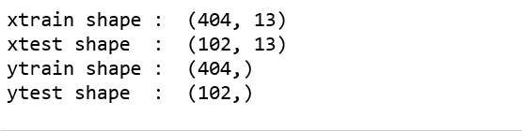
Applying Linear Regression Model to the dataset and predicting the prices.

# Fitting Multi Linear regression model to training model
from sklearn.linear_model import LinearRegression
regressor = LinearRegression()
regressor.fit(xtrain, ytrain)

# predicting the test set results
y_pred = regressor.predict(xtest)

Plotting Scatter graph to show the prediction results – ‘y_true’ value vs ‘y_pred’ value.

# Plotting Scatter graph to show the prediction
# results - 'ytrue' value vs 'y_pred' value
plt.scatter(ytest, y_pred, c = 'green')
plt.xlabel("Price: in $1000's")
plt.ylabel("Predicted value")
plt.title("True value vs predicted value : Linear Regression")
plt.show()

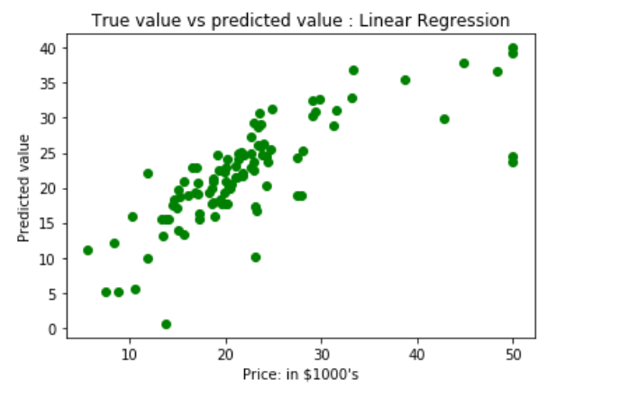
Results of Linear Regression i.e. Mean Squared Error and Mean Absolute Error.

Boston Housing Data: This dataset was taken from the StatLib library and is maintained by Carnegie Mellon University. This dataset concerns the housing prices in the housing city of Boston. The dataset provided has 506 instances with 13 features.
The Description of the dataset is taken from the below reference as shown in the table follows:

Let’s make the Linear Regression Model, predicting housing prices by Inputting Libraries and datasets.

# Importing Libraries
import numpy as np
import pandas as pd
import matplotlib.pyplot as plt

# Importing Data
from sklearn.datasets import load_boston
boston = load_boston()

The shape of input Boston data and getting feature_names.

boston.data.shape

boston.feature_names

Converting data from nd-array to data frame and adding feature names to the data

data = pd.DataFrame(boston.data)
data.columns = boston.feature_names

data.head(10)

Adding the ‘Price’ column to the dataset

# Adding 'Price' (target) column to the data
boston.target.shape

data['Price'] = boston.target
data.head()

Description of Boston dataset

data.describe()

Info of Boston Dataset

data.info()

Getting input and output data and further splitting data to training and testing dataset.

# Input Data
x = boston.data

# Output Data
y = boston.target

# splitting data to training and testing dataset.

#from sklearn.cross_validation import train_test_split
#the submodule cross_validation is renamed and deprecated to model_selection
from sklearn.model_selection import train_test_split

xtrain, xtest, ytrain, ytest = train_test_split(x, y, test_size =0.2,
random_state = 0)

print("xtrain shape : ", xtrain.shape)
print("xtest shape : ", xtest.shape)
print("ytrain shape : ", ytrain.shape)
print("ytest shape : ", ytest.shape)

Applying Linear Regression Model to the dataset and predicting the prices.

# Fitting Multi Linear regression model to training model
from sklearn.linear_model import LinearRegression
regressor = LinearRegression()
regressor.fit(xtrain, ytrain)

# predicting the test set results
y_pred = regressor.predict(xtest)

Plotting Scatter graph to show the prediction results – ‘y_true’ value vs ‘y_pred’ value.

# Plotting Scatter graph to show the prediction
# results - 'ytrue' value vs 'y_pred' value
plt.scatter(ytest, y_pred, c = 'green')
plt.xlabel("Price: in $1000's")
plt.ylabel("Predicted value")
plt.title("True value vs predicted value : Linear Regression")
plt.show()

Results of Linear Regression i.e. Mean Squared Error and Mean Absolute Error.

from sklearn.metrics import mean_squared_error, mean_absolute_error
mse = mean_squared_error(ytest, y_pred)
mae = mean_absolute_error(ytest,y_pred)
print("Mean Square Error : ", mse)
print("Mean Absolute Error : ", mae)

Mean Square Error : 33.448979997676496
Mean Absolute Error : 3.8429092204444966
As per the result, our model is only 66.55% accurate. So, the prepared model is not very good for predicting housing prices. One can improve the prediction results using many other possible machine learning algorithms and techniques.
Here are a few further steps on how you can improve your model.
- Feature Selection
- Cross-Validation
- Hyperparameter Tuning

Python | Implementation of Polynomial Regression
Polynomial Regression is a form of linear regression in which the relationship between the independent variable x and dependent variable y is modeled as an nth degree polynomial. Polynomial regression fits a nonlinear relationship between the value of x and the corresponding conditional mean of y, denoted E(y |x)
Why Polynomial Regression:

- There are some relationships that a researcher will hypothesize is curvilinear. Clearly, such types of cases will include a polynomial term.
- Inspection of residuals. If we try to fit a linear model to curved data, a scatter plot of residuals (Y-axis) on the predictor (X-axis) will have patches of many positive residuals in the middle. Hence in such a situation, it is not appropriate.
- An assumption in usual multiple linear regression analysis is that all the independent variables are independent. In polynomial regression model, this assumption is not satisfied.
Uses of Polynomial Regression:
These are basically used to define or describe non-linear phenomena such as:
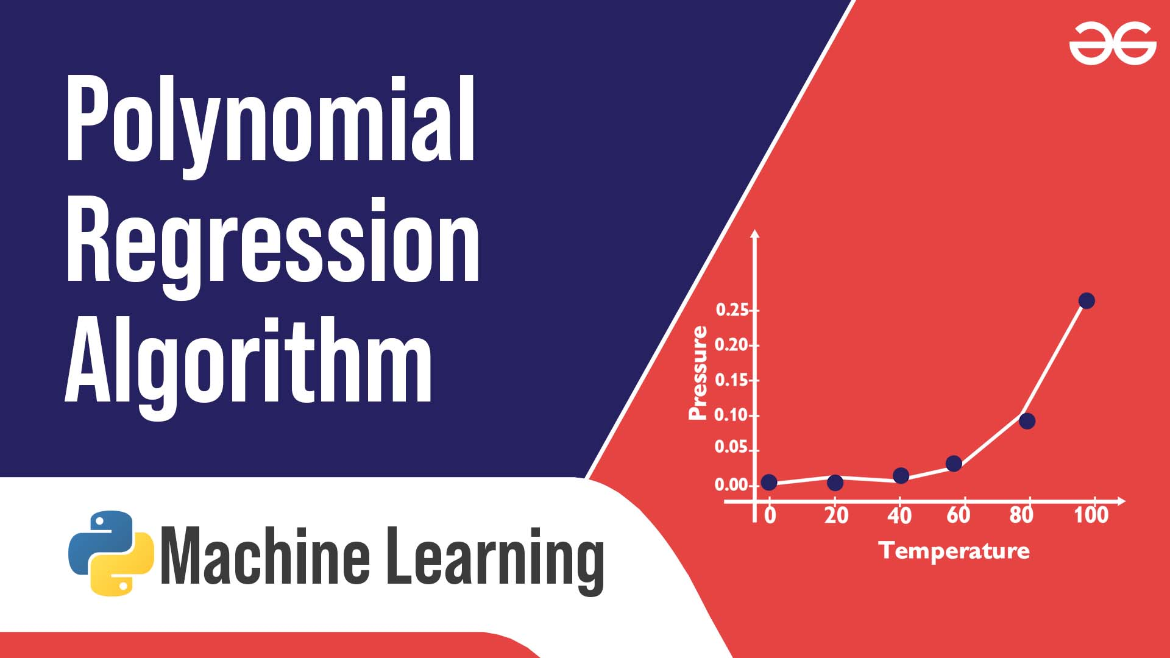
- The growth rate of tissues.
- Progression of disease epidemics
- Distribution of carbon isotopes in lake sediments
The basic goal of regression analysis is to model the expected value of a dependent variable y in terms of the value of an independent variable x. In simple regression, we used the following equation –
y = a + bx + e
Here y is a dependent variable, a is the y-intercept, b is the slope and e is the error rate.
In many cases, this linear model will not work out For example if we analyzing the production of chemical synthesis in terms of temperature at which the synthesis take place in such cases we use a quadratic model
y = a + b1x + b2^2 + e
Here y is the dependent variable on x, a is the y-intercept and e is the error rate.
In general, we can model it for nth value.
y = a + b1x + b2x^2 +....+ bnx^n
Since regression function is linear in terms of unknown variables, hence these models are linear from the point of estimation.
Hence through the Least Square technique, let’s compute the response value that is y.
Polynomial Regression in Python:
To get the Dataset used for the analysis of Polynomial Regression, click here.
Step 1: Import libraries and dataset
Import the important libraries and the dataset we are using to perform Polynomial Regression.

# Importing the libraries
import numpy as np
import matplotlib.pyplot as plt
import pandas as pd

# Importing the dataset
datas = pd.read_csv('data.csv')
datas

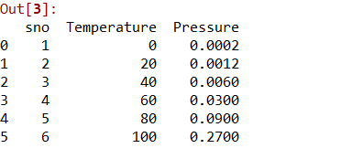
Step 2: Dividing the dataset into 2 components
Divide dataset into two components that is X and y.X will contain the Column between 1 and 2. y will contain the 2 columns.

X = datas.iloc[:, 1:2].values
y = datas.iloc[:, 2].values

Step 3: Fitting Linear Regression to the dataset
Fitting the linear Regression model On two components.

# Fitting Linear Regression to the dataset
from sklearn.linear_model import LinearRegression
lin = LinearRegression()

lin.fit(X, y)

Step 4: Fitting Polynomial Regression to the dataset
Fitting the Polynomial Regression model on two components X and y.

# Fitting Polynomial Regression to the dataset
from sklearn.preprocessing import PolynomialFeatures

poly = PolynomialFeatures(degree = 4)
X_poly = poly.fit_transform(X)

poly.fit(X_poly, y)
lin2 = LinearRegression()
lin2.fit(X_poly, y)

Step 5: In this step, we are Visualising the Linear Regression results using a scatter plot.

# Visualising the Linear Regression results
plt.scatter(X, y, color = 'blue')

plt.plot(X, lin.predict(X), color = 'red')
plt.title('Linear Regression')
plt.xlabel('Temperature')
plt.ylabel('Pressure')

plt.show()

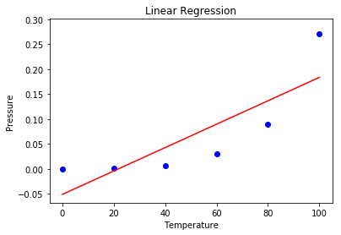
Step 6: Visualising the Polynomial Regression results using a scatter plot.

# Visualising the Polynomial Regression results
plt.scatter(X, y, color = 'blue')

plt.plot(X, lin2.predict(poly.fit_transform(X)), color = 'red')
plt.title('Polynomial Regression')
plt.xlabel('Temperature')
plt.ylabel('Pressure')

plt.show()

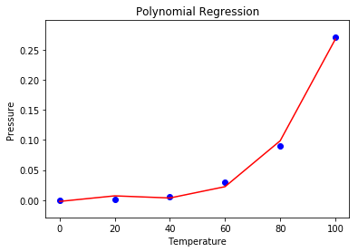
Step 7: Predicting new results with both Linear and Polynomial Regression. Note that the input variable must be in a numpy 2D array.

# Predicting a new result with Linear Regression after converting predict variable to 2D array
pred = 110.0
predarray = np.array([[pred]])
lin.predict(predarray)

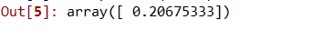

# Predicting a new result with Polynomial Regression after converting predict variable to 2D array
pred2 = 110.0
pred2array = np.array([[pred2]])
lin2.predict(poly.fit_transform(pred2array))

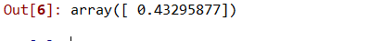
Advantages of using Polynomial Regression:
- A broad range of functions can be fit under it.
- Polynomial basically fits a wide range of curvatures.
- Polynomial provides the best approximation of the relationship between dependent and independent variables.
Disadvantages of using Polynomial Regression
- These are too sensitive to the outliers.
- The presence of one or two outliers in the data can seriously affect the results of nonlinear analysis.
- In addition, there are unfortunately fewer model validation tools for the detection of outliers in nonlinear regression than there are for linear regression.

Softmax Regression using TensorFlow
This article discusses the basics of Softmax Regression and its implementation in Python using TensorFlow library.

What is Softmax Regression?
Softmax regression (or multinomial logistic regression) is a generalization of logistic regression to the case where we want to handle multiple classes.
A gentle introduction to linear regression can be found here:
Understanding Logistic Regression
In binary logistic regression we assumed that the labels were binary, i.e. for observation,
But consider a scenario where we need to classify an observation out of two or more class labels. For example, digit classification. Here, the possible labels are:
In such cases, we can use Softmax Regression.
Let us first define our model:
- Let the dataset have ‘m’ features and ‘n’ observations. Also, there are ‘k’ class labels, i.e every observation can be classified as one of the ‘k’ possible target values. For example, if we have a dataset of 100 handwritten digit images of vector size 28×28 for digit classification, we have, n = 100, m = 28×28 = 784 and k = 10.
- Feature matrix
The feature matrix, , is represented as: 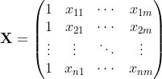 Here, denotes the values of feature for observation. The matrix has dimensions:
- Weight matrix
We define a weight matrix, as: 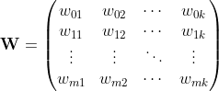Here, represents the weight assigned to feature for class label. The matrix has dimensions:. Initially, weight matrix is filled using some normal distribution.
- Logit score matrix
Then, we define our net input matrix(also called logit score matrix), , as:
Z = XW
The matrix has dimensions: .
Currently, we are taking an extra column in feature matrix, and an extra row in weight matrix, . These extra columns and rows correspond to the bias terms associated with each prediction. This could be simplified by defining an extra matrix for bias, of size where . (In practice, all we need is a vector of size and some broadcasting techniques for the bias terms!)
So, the final score matrix, is:
Z = XW+b
where matrix has dimensions while has dimensions . But matrix still has same value and dimensions!
But what does matrix signify? Actually, is the likelihood of label j for observation. It is not a proper probability value but can be considered as a score given to each class label for each observation!
Let us define as the logit score vector for observation.
For example, let the vector represents the score for each of the class labels in handwritten digit classification problem for observation. Here, the max score is 5.2 which corresponds to class label ‘3’. Hence, our model currently predicts the observation/image as ‘3’.
- Softmax layer
It is harder to train the model using score values since it is hard to differentiate them while implementing Gradient Descent algorithm for minimizing the cost function. So, we need some function which normalizes the logit scores as well as makes them easily differentiable!In order to convert the score matrix to probabilities, we use Softmax function.
For a vector , softmax function is defined as: 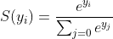 So, softmax function will do 2 things:
1. convert all scores to probabilities.
2. sum of all probabilities is 1.
Recall that in Binary Logistic classifier, we used sigmoid function for the same task. Softmax function is nothing but a generalization of sigmoid function! Now, this softmax function computes the probability that the training sample belongs to class given the logits vector as:
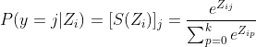
In vector form, we can simply write:
For simplicity, let denote the softmax probability vector for observation.
- One-hot encoded target matrix
Since softmax function provides us with a vector of probabilities of each class label for a given observation, we need to convert target vector in the same format to calculate the cost function! Corresponding to each observation, there is a target vector (instead of a target value!) composed of only zeros and ones where only correct label is set as 1. This technique is called one-hot encoding.See the diagram given below for a better understanding:
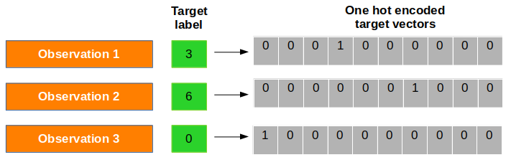
Now, we denote one-hot encoding vector for observation as
- Cost function
Now, we need to define a cost function for which, we have to compare the softmax probabilities and one-hot encoded target vector for similarity. We use the concept of Cross-Entropy for the same. The Cross-entropy is a distance calculation function which takes the calculated probabilities from softmax function and the created one-hot-encoding matrix to calculate the distance. For the right target classes, the distance values will be lesser, and the distance values will be larger for the wrong target classes.We define cross entropy, for observation with softmax probability vector, and one-hot target vector, as: 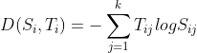
And now, cost function, can be defined as the average cross entropy, i.e:
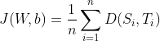
and the task is to minimize this cost function!
- Gradient Descent algorithm
In order to learn our softmax model via gradient descent, we need to compute the derivative: and which we then use to update the weights and biases in opposite direction of the gradient: and for each class where and is learning rate.Using this cost gradient, we iteratively update the weight matrix until we reach a specified number of epochs (passes over the training set) or reach the desired cost threshold.
Implementation
Let us now implement Softmax Regression on the MNIST handwritten digit dataset using TensorFlow library.
For a gentle introduction to TensorFlow, follow this tutorial:
Introduction to TensorFlow
Step 1: Import the dependencies
First of all, we import the dependencies.
import tensorflow as tf
import numpy as np
import matplotlib.pyplot as plt

Step 2: Download the data
TensorFlow allows you to download and read in the MNIST data automatically. Consider the code given below. It will download and save data to the folder, MNIST_data, in your current project directory and load it in current program.
from tensorflow.examples.tutorials.mnist import input_data
mnist = input_data.read_data_sets("MNIST_data/", one_hot=True)

Extracting MNIST_data/train-images-idx3-ubyte.gz
Extracting MNIST_data/train-labels-idx1-ubyte.gz
Extracting MNIST_data/t10k-images-idx3-ubyte.gz
Extracting MNIST_data/t10k-labels-idx1-ubyte.gz
Step 3: Understanding data
Now, we try to understand the structure of the dataset.
The MNIST data is split into three parts: 55,000 data points of training data (mnist.train), 10,000 points of test data (mnist.test), and 5,000 points of validation data (mnist.validation).
Each image is 28 pixels by 28 pixels which has been flattened into 1-D numpy array of size 784. Number of class labels is 10. Each target label is already provided in one-hot encoded form.
print("Shape of feature matrix:", mnist.train.images.shape)
print("Shape of target matrix:", mnist.train.labels.shape)
print("One-hot encoding for 1st observation:\n", mnist.train.labels[0])

# visualize data by plotting images
fig,ax = plt.subplots(10,10)
k = 0
for i in range(10):
for j in range(10):
ax[i][j].imshow(mnist.train.images[k].reshape(28,28), aspect='auto')
k += 1
plt.show()

Output:
Shape of feature matrix: (55000, 784)
Shape of target matrix: (55000, 10)
One-hot encoding for 1st observation:
[ 0. 0. 0. 0. 0. 0. 0. 1. 0. 0.]
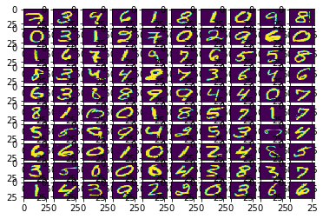
Step 4: Defining computation graph
Now, we create a computation graph.
# number of features
num_features = 784
# number of target labels
num_labels = 10
# learning rate (alpha)
learning_rate = 0.05
# batch size
batch_size = 128
# number of epochs
num_steps = 5001

# input data
train_dataset = mnist.train.images
train_labels = mnist.train.labels
test_dataset = mnist.test.images
test_labels = mnist.test.labels
valid_dataset = mnist.validation.images
valid_labels = mnist.validation.labels

# initialize a tensorflow graph
graph = tf.Graph()

with graph.as_default():
"""
defining all the nodes
"""

# Inputs
tf_train_dataset = tf.placeholder(tf.float32, shape=(batch_size, num_features))
tf_train_labels = tf.placeholder(tf.float32, shape=(batch_size, num_labels))
tf_valid_dataset = tf.constant(valid_dataset)
tf_test_dataset = tf.constant(test_dataset)

# Variables.
weights = tf.Variable(tf.truncated_normal([num_features, num_labels]))
biases = tf.Variable(tf.zeros([num_labels]))

# Training computation.
logits = tf.matmul(tf_train_dataset, weights) + biases
loss = tf.reduce_mean(tf.nn.softmax_cross_entropy_with_logits(
labels=tf_train_labels, logits=logits))

# Optimizer.
optimizer = tf.train.GradientDescentOptimizer(learning_rate).minimize(loss)

# Predictions for the training, validation, and test data.
train_prediction = tf.nn.softmax(logits)
valid_prediction = tf.nn.softmax(tf.matmul(tf_valid_dataset, weights) + biases)
test_prediction = tf.nn.softmax(tf.matmul(tf_test_dataset, weights) + biases)

Some important points to note:
- For the training data, we use a placeholder that will be fed at run time with a training minibatch. The technique of using minibatches for training model using gradient descent is termed as Stochastic Gradient Descent.
In both gradient descent (GD) and stochastic gradient descent (SGD), you update a set of parameters in an iterative manner to minimize an error function. While in GD, you have to run through ALL the samples in your training set to do a single update for a parameter in a particular iteration, in SGD, on the other hand, you use ONLY ONE or SUBSET of training sample from your training set to do the update for a parameter in a particular iteration. If you use SUBSET, it is called Minibatch Stochastic gradient Descent. Thus, if the number of training samples are large, in fact very large, then using gradient descent may take too long because in every iteration when you are updating the values of the parameters, you are running through the complete training set. On the other hand, using SGD will be faster because you use only one training sample and it starts improving itself right away from the first sample. SGD often converges much faster compared to GD but the error function is not as well minimized as in the case of GD. Often in most cases, the close approximation that you get in SGD for the parameter values are enough because they reach the optimal values and keep oscillating there.
- The weight matrix is initialized using random values following a (truncated) normal distribution. This is achieved using tf.truncated_normal method. The biases get initialized to zero using tf.zeros method.
- Now, we multiply the inputs with the weight matrix, and add biases. We compute the softmax and cross-entropy using tf.nn.softmax_cross_entropy_with_logits (it’s one operation in TensorFlow, because it’s very common, and it can be optimized). We take the average of this cross-entropy across all training examples using tf.reduce_mean method.
- We are going to minimize the loss using gradient descent. For this, we use tf.train.GradientDescentOptimizer.
- train_prediction, valid_prediction and test_prediction are not part of training, but merely here so that we can report accuracy figures as we train.
Step 5: Running the computation graph
Since we have already built the computation graph, now it’s time to run it through a session.
# utility function to calculate accuracy
def accuracy(predictions, labels):
correctly_predicted = np.sum(np.argmax(predictions, 1) == np.argmax(labels, 1))
accu = (100.0 * correctly_predicted) / predictions.shape[0]
return accu

with tf.Session(graph=graph) as session:
# initialize weights and biases
tf.global_variables_initializer().run()
print("Initialized")

for step in range(num_steps):
# pick a randomized offset
offset = np.random.randint(0, train_labels.shape[0] - batch_size - 1)

# Generate a minibatch.
batch_data = train_dataset[offset:(offset + batch_size), :]
batch_labels = train_labels[offset:(offset + batch_size), :]

# Prepare the feed dict
feed_dict = {tf_train_dataset : batch_data,
tf_train_labels : batch_labels}

# run one step of computation
_, l, predictions = session.run([optimizer, loss, train_prediction],
feed_dict=feed_dict)

if (step % 500 == 0):
print("Minibatch loss at step {0}: {1}".format(step, l))
print("Minibatch accuracy: {:.1f}%".format(
accuracy(predictions, batch_labels)))
print("Validation accuracy: {:.1f}%".format(
accuracy(valid_prediction.eval(), valid_labels)))

print("\nTest accuracy: {:.1f}%".format(
accuracy(test_prediction.eval(), test_labels)))

Output:
Initialized
Minibatch loss at step 0: 11.68728256225586
Minibatch accuracy: 10.2%
Validation accuracy: 14.3%
Minibatch loss at step 500: 2.239773750305176
Minibatch accuracy: 46.9%
Validation accuracy: 67.6%
Minibatch loss at step 1000: 1.0917563438415527
Minibatch accuracy: 78.1%
Validation accuracy: 75.0%
Minibatch loss at step 1500: 0.6598564386367798
Minibatch accuracy: 78.9%
Validation accuracy: 78.6%
Minibatch loss at step 2000: 0.24766433238983154
Minibatch accuracy: 91.4%
Validation accuracy: 81.0%
Minibatch loss at step 2500: 0.6181786060333252
Minibatch accuracy: 84.4%
Validation accuracy: 82.5%
Minibatch loss at step 3000: 0.9605385065078735
Minibatch accuracy: 85.2%
Validation accuracy: 83.9%
Minibatch loss at step 3500: 0.6315320730209351
Minibatch accuracy: 85.2%
Validation accuracy: 84.4%
Minibatch loss at step 4000: 0.812285840511322
Minibatch accuracy: 82.8%
Validation accuracy: 85.0%
Minibatch loss at step 4500: 0.5949224233627319
Minibatch accuracy: 80.5%
Validation accuracy: 85.6%
Minibatch loss at step 5000: 0.47554320096969604
Minibatch accuracy: 89.1%
Validation accuracy: 86.2%

Test accuracy: 86.5%
Some important points to note:
- In every iteration, a minibatch is selected by choosing a random offset value using np.random.randint method.
- To feed the placeholders tf_train_dataset and tf_train_label, we create a feed_dict like this:
feed_dict = {tf_train_dataset : batch_data, tf_train_labels : batch_labels}
- A shortcut way of performing one step of computation is:
_, l, predictions = session.run([optimizer, loss, train_prediction], feed_dict=feed_dict)
This node returns the new values of loss and predictions after performing optimization step.
This brings us to the end of the implementation. Complete code can be found here.
Finally, here are some points to ponder upon:
- You can try to tweak with the parameters like learning rate, batch size, number of epochs, etc and achieve better results. You can also try a different optimizer like tf.train.AdamOptimizer.
- Accuracy of above model can be improved by using a neural network with one or more hidden layers. We will discuss its implementation using TensorFlow in some upcoming articles.
- Softmax Regression vs. k Binary Classifiers
One should be aware of the scenarios where softmax regression works and where it doesn’t. In many cases, you may need to use k different binary logistic classifiers for each of the k possible values of the class label.
Suppose you are working on a computer vision problem where you’re trying to classify images into three different classes:
Case 1: Suppose that your classes are indoor_scene, outdoor_urban_scene, and outdoor_wilderness_scene.
Case 2: Suppose your classes are indoor_scene, black_and_white_image, and image_has_people.
In which case you would use Softmax Regression classifier and in which case you would use 3 Binary Logistic Regression classifiers?
This will depend on whether the 3 classes are mutually exclusive.
In case 1, a scene can be either indoor_scene, outdoor_urban_scene or outdoor_wilderness_scene. So, assuming that each training example is labeled with exactly one of the 3 classes, we should build a softmax classifier with k = 3.
However, in case 2, the classes are not mutually exclusive since a scene can be both indoor and have people in it. So, in this case, it would be more appropriate to build 3 binary logistic regression classifiers. This way, for each new scene, your algorithm can separately decide whether it falls into each of the 3 categories.
References:
- http://www.kdnuggets.com/2016/07/softmax-regression-related-logistic-regression.html
- https://classroom.udacity.com/courses/ud730
- http://ufldl.stanford.edu/wiki/index.php/Softmax_Regression

